**Final Year Project Logbook**

Week 4 (10.11-10.17)

1. Current blueprint of smart glasses
2. Features to realize:

* All components are integrated in the glasses frame, including two legs and the front section. Three PCBs are connected using two 10-pin FFC (3cm).
* The power consumption of the whole system is very low, it should provide navigation continuously for around two hours with a typical 250 mAh Li-Po battery.
* Four LEDs to alert the user about the current deviation from the correct direction, two buzzers to warn the user when the deviation is very big. These components can also be used as feedback system to provide information.
* IMUs such as accelerometer and gyroscope are used to collect the motional data during orienteering or sailing, these will be logged into a micro SD card for further analysis on PC to provide statistics like average speed or step length for user.

1. List of components (Yes/TBD/No):

* (Yes) ATMega328P as the main microcontroller (with embedded Arduino framework to accelerate developing efficiency)
* (Yes) FT232RL as a USB to UART transceiver for the communication between PC and ATMega328P
* (Yes) Four green SMD LEDs to provide alert (Human’s eyes are most sensitive to the wavelength around 550 nm)
* (Yes) a digital compass IC to sense the magnetic field of earth (in small SMD package, preferably VQFN or similar, with low current consumption, 3.3V or 5V, no external oscillator required)
* (Yes) an IC (with similar requirement as above) that is integrated with both accelerometer and gyroscope, probably also the digital compass
* (Yes) a charging or battery management IC to accept external 5V input to charge the battery in the leg, with small LEDs to indicate the charging status
* (Yes) a voltage boost IC to increase the 3.7V from battery to 5 V for the system to use. Potentially also LDOs to regulate the voltage at 5V or 3.3V.
* (Yes) a 2GB or 4GB micro SD card to record the data from IMUs, together with a micro SD card connector to the PCB.
* (Yes) a 250-300 mAh Li-Po battery to power the entire system. Typically the size is 20*30*5mm.
* (Yes) 3 customized PCBs. One for MCU, IMUs, Compass, Communication port and Buzzer, another for buttons, Buzzer, battery, charging circuit, LDOs and logging system. The third one for LEDs and current path between previous two boards.
* (TBD) 2-3 physical buttons to control the power on and off, to allow user to decide whether to turn off the piezo buzzer or LEDs, to allow user to lock the current direction as the desiring direction for navigation, to allow user to switch between different modes, to allow user to reset the entire system and start from beginning……
* (TBD) 2 buzzers located at each leg, to warn the user when there is a significant deviation, for example over 90 degrees. Sound signal is preferred over vibrating signal as the user will be running in an uneven environment during orienteering, it may be difficult for the user to distinguish between the vibration of the glasses itself or the vibration of the buzzer.
* (TBD) Tapping for piezo components to generate signal for MCU to detect, or use capacitance detecting touching PCB design for interaction. The main concern for these methods is because orienteering is a fierce and demanding sport, the user is very likely to adjust the position of glasses in case that it slips off because of sweating. It is possible for user to send out unwanted signal to the MCU due to this adjustment, and it will be impractical for user to stop on purpose to calibrate the device again, thus this should be totally avoided.
* (No) GPS Module. This decision is made based on overall component volume control and power consumption. Even the highly integrated commercial GPS module has the size of 20*22*6mm (a similar size to the battery) and an operating current of 50mA (250mW). This is a large power for a 0.93 Wh battery, it is almost certain the system will not last for two hours as specified.

1. Basic Risk Management Consideration
2. The components used for this project are easy to order from suppliers like Dig-key or Mouser. Most component choices have been checked on their websites, they are in stock, not expensive, and also have many alternatives. This is generally not considered as a risk.
3. The 3D printed glasses frame is also not at much risk, since the EEE department has a designated 3D printing lab. Although it may take some trials and errors, it is expected that the 3D printing workshop will be able to support this.
4. The main risk comes from manufacturing the PCB. This integrated glasses heavily rely on a well-designed and functional PCB, but it is possible the eventual design does not work properly or because of logistic reasons, the PCB cannot be manufactured or shipped to university. In this case, the compactness of the design will be abandoned and the revised version will be based on existing Arduino Nano board, commercially available IMU and compass modules that can be directly connected to Arduino via Dupont wires. The other components can be connected together on a Veroboard and an additional 3D printed box will be designed to contain all “magnified” components and it will be located at the back side of user’s head.
5. Research about current designs available and technical terms

**Ergonomic**: “Ergonomics is the study of the interaction between people and machines and the factors that affect the interaction. Its purpose is to improve the performance of systems by improving human machine interaction. This can be done by “designing-in” a better interface or by “designing-out” factors in the work environment, in the task or in the organisation of work that degrade human-machine performance” – R.S. Bridger *Introduction to Ergonomics*

(Relevance: seek for an appropriate interaction method between the glasses and user, make it easy, efficient, intuitive/try to optimise wearer’s comfort and glasses’ durability)

**Peripheral Vision**: “When I look at something it is as if a pointer extends from my eye to an object. The ‘pointer’ is my gaze, and what it touches I see most clearly. Things are less distinct as they lie farther from my gaze. It is not as if these things go out of focus—but rather it's as if somehow they lose the quality of form” --- Lettvin *On seeing sidelong*

(Relevance: How the user is going to see the alert from LEDs while maintaining sight at the front activities (uneven path, condition of the water surface), and will the user get the information efficiently and comfortably from the LEDs that are really close to his/her eyes)

Relevant papers:

1. Step counter, step length estimation, orientation Kalman filter, direction of motion estimation with head rotation detection, including algorithm and mathematical derivation – Darrel Loh etc. *Pedestrian Dead Reckoning With Smart glasses and Smartwatch*
2. A proposed design of a PDR system integrated with accelerometer, gyroscope, magnetometer, GPS receiver, pressure sensor. The design is packaged into a box, similar to the back-up plan of this project. – Miguel etc. *A New PDR Navigation Device for Challenging Urban Environment*
3. A proposed design of a smart glasses for turn-by-turn navigation based on LED indictor. The requirements of this project are very similar to a simplified version of this proposed design. – Xiaoxiao *Designing Turn-by-Turn Navigation System for Customized Wearable User Interface.*

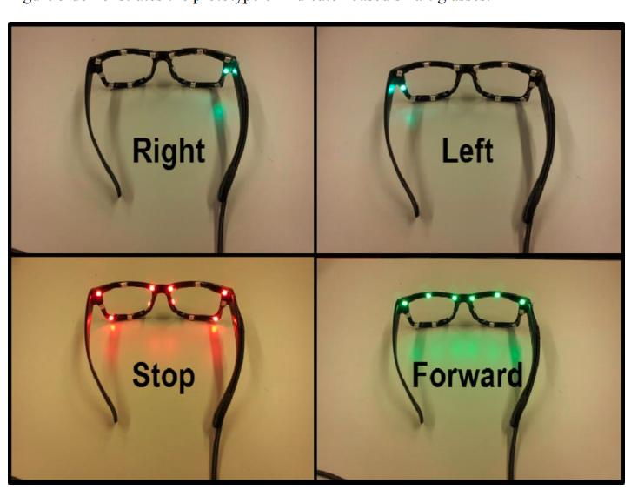

(*More background research needs to be conducted to prepare for proposal writing)

Week 5 (10.18-10.24)

1. Preparation for moderator meeting about proposal
2. Review about “High Frequency Gate Driver for Wide-Band-Gap Semiconductors”

* Need of high frequency operation of power converter à two promising materials à exploit potential from them à gate drive design
* Aims, objectives and deliverables (very detailed objectives)
* Why the following section is literature review? Supposed to be milestones and risk management? (case-study and literature review are integrated with current proposed design?)
* No sign of risk management
* No sign of page number
* A complete Gannt chart and a table indicating milestones

1. Meeting Minutes
2. It is important to make the proposal easy to understand and mark. Each section should be clearly laid out with proper sequence, and the structure should be easy to follow.
3. Better to use recent/latest reference, to identify the most recent advancement in the area related with project.
4. Good presentation of the proposal is also important. Spelling mistakes are very easy to correct using the spelling/grammar checker built in Word.
5. Deliverables and Milestones should be created logically and based on the realistic progress of the project.
6. Use a well-designed Gannt chart to specify the time plan of the progress is critical. If it already describes everything about the project time management, there is no need to add extra words for explanation
7. More background researches
8. Draft of aims and objectives
9. The aim of this project is to design a smart glasses frame to guide the wearer on a stable compass heading during sports such as orienteering and sailing. The glasses frame should be light, compact, stable on wear’s face, easy to interact and can last for a few hours without being recharged. The wearer should be able to lock onto a certain direction and know how to correct the current path based on the feedback from the glasses. The glasses should also be able to track the motional information of the wearer and log it into a SD card for later analysis.
10. Objectives:

* The followings will not be conducted strictly in sequence when completing the project. This will be illustrated and reflected in the Gantt chart.

* Extensive literature review in the state-of-art wearable technologies/devices for sport purpose or navigation purpose. The marketing needs and the driver for the technology also need to be covered. (This background information will summarize the current conditions of similar technologies and support the fact that there’s no identical device (to my project) existing in the market, thus developing such a pair of smart glasses is meaningful and can be a complementary device to the market.
* Research about relevant sensors and ICs and complete a list of components required for the project, place the order as early as possible (Logistic is not totally predictable with COVID-19, it is better to acquire the components early or search for alternatives if the first choice is not available)
* Design three PCBs that will be installed in the left leg, right leg and frontal frame. The schematics and PCBs will be designed by Altium Designer. (The PCBs are designed first because of two reasons. The first is that the dimensions of them are critical for the frame design of glasses. The PCB may only be manufactured once, but the frame design can be adjusted for multiple generations as university has a 3D printing Lab. The second reason is that it takes quite a long time to manufacture and ship, it will be better to order it first, in case of something unpredictable happens, there is still some time to adjust the plan)
* Order PCBs from manufacturers like JLC PCB
* Study about a CAD software to construct the 3D model of glasses frame.
* Design and 3D print the glasses frame, test it with the PCBs (if available), to check dimensions, modify the design if needed
* Optimize the model of glasses frame to improve its shock resistance and waterproof functionality. (This is because the glasses will be used in some fierce sports such as orienteering, the operating environment will be harsh. These features will make sure its durability is acceptable)
* Solder the PCBs and debug them. Try to download the firmware of Arduino first to make sure the MCU is working.
* Programme the MCU to add the functionalities one by one (component by component). The major workload will focus on collecting motional data from IMUs and manipulate them to provide statistical information during a certain activity. Possible information to extract: average speed, step length, estimated track, deviations times……
* Assemble the entire system to verify the overall results. Conduct experiments to validate the performance and collect data to compare the realistic situation with the ideal one. Optimize the algorithm based on user experience and the data analysed.
* Complete the thesis to summarize the entire project development and include relevant analysis and potential improvements.

1. Draft of deliverables, milestones and risks
2. Deliverables:

* Completed and extensive literature review
* A list of all components required for this project, including their potential alternatives, manufacturer and website to order
* Completed schematic and PCB designs
* 3D Printed glasses frame
* Optimized glasses frame to better comfortability, shock resistance and waterproof ability
* Fully soldered PCBs
* Arduino programme to realize all basic functions
* Accomplished logging system and relevant algorithms to process the collected data
* Debugged and validated smart glasses with all functionalities

1. Milestones:

* Three PCBs are designed and the order is placed
* The glasses frame is designed and printed
* The whole system is assembled and all basic functions are verified
* The logging system works properly and the algorithm for data analysis is developed and deployed
* Final report is completed and submitted

1. Risks: The basic risk estimation and methods to mitigate are covered in previous section “Basic Risk Management Consideration”

Week 6 (10.25-10.31)

1. Supervisor Meeting Minutes:
2. Inertial navigation is a completely different solution from GPS. It needs to integrate acceleration with respect to time to obtain real-time velocity and integrated again to calculate distance. The actual locations needs to be derived from this information, oppositely the locations are directly available in GPS navigation. The addition of the vectors obtained from IMUs will almost definitely lead to some discrepancy to actual situation, for example the accelerometer will not be able to detect “DC” circumstance, in which the velocity remains same. This will be common in sailing, as the wave is very likely to move at a steady speed that is hard to detect. This limitation and the discrepancy from reality can be discussed in the thesis to analyse the algorithm or propose potential improvement.
3. The current risk management is OK
4. In a proposal, objectives and aims should be short and direct, usually can be concluded by one sentence.
5. Have a look at Strava
6. Choose a CAD to design the 3D model of glasses frame.
7. Finalised Project Objectives:

**Preparation Stage**

1. Extensive literature review in the state-of-the-art wearable technologies for sport purpose and navigation purpose, meanwhile also covering the marketing needs and the driver for the technology.
2. Research about miniature IMUs, compass and other ICs required for the project and complete a list of components for order placement.
3. Design an overall architecture of the entire system and confirm the functions to realize.

**Design and Construction Stage**

1. Use Altium Designer to design three PCBs that will be installed in the left leg, right leg and frontal frame of the glasses, and order the PCBs from manufacturer.
2. Design and 3D print the glasses frame and test its compatibility with PCBs (if available).
3. Solder the PCBs and verify every sensor is working properly while applying necessary debugging procedure.
4. Programme the MCU to add basic navigation function first, then focus on logging system and signal processing.
5. Develop PC scripts to read the data from glasses and manipulate them to output required results such as trajectory, distance and average speed.

**Validation Stage**

1. Assemble the entire system to validate all desiring functions and exhaust possible tests to assess the performance by recording experimental data.
2. Optimise the system from both hardware and software perspectives to improve user experience
3. Complete the thesis to summarize the entire project development and include relevant analysis as well as potential improvements.
4. Finalised Project Deliverables

**Deliverables**

1. Completed literature review covering the project area and field, including the marketing needs, technology driver and potential ethical, social problems.
2. A list of all components required for this project, including their alternatives, manufacturers and the websites to order.
3. Three completed schematic and PCB designs
4. 3D printed glasses frame
5. Fully soldered and debugged PCBs
6. C programme that can realize the basic navigation function
7. C programme that can log all data successfully into SD card during activity and the data can be exported for analysis
8. PC scripts for post-processing the data from glasses to generate statistical results
9. Optimised human-machine interaction and greater comfortability and durability of glasses frame
10. Debugged and validated smart glasses with all functionalities
11. Finalised Project Milestones:

**Milestones**

1. Three PCBs are designed and fabricated
2. Glasses frame is designed and printed
3. The whole system is assembled and basic navigation functions are verified
4. The logging system is working properly and corresponding signal processing algorithms on PC are developed
5. Final project report is completed and submitted
6. 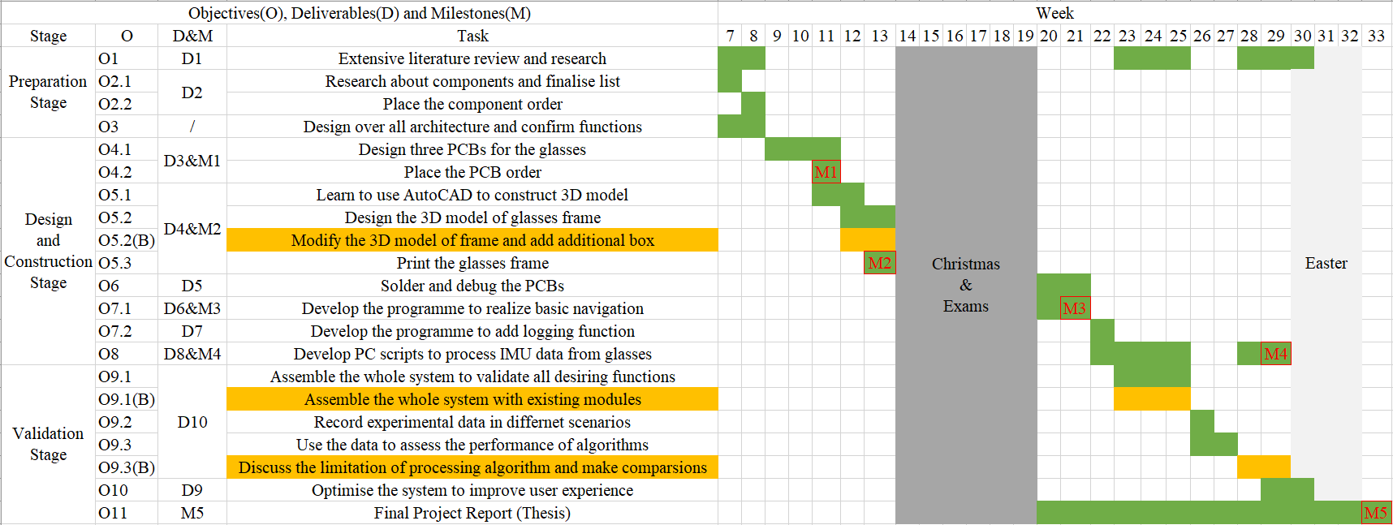Time plan
7. Research about Strava
8. Features:

* Measure the performance of wearer using existing hardware like phone, GPS watch, head unit, heart rate monitor or power meter. Analyse the data in a journey to provide statistical results in a user friendly way.
* Share the location in real time with others
* Provide the route and trail resources of other athletes and relevant navigation based on these routes.

1. Application in the project: Strava can be used to collect and analyse complementary data for reference when validating the glasses. The route, performance statistics can be compared to the version generated by glasses for discussion.
2. Choice of modelling CAD

Solidworks can be the best CAD choice to construct mechanical components for beginners. However the university is only giving licence to mechanical student for it. Sketchup is a software for 3D architecture drafting, probably not suitable for modelling small 3D glasses frame. AutoCAD is the best choice for 2D drawing of components and can be used to create simple 3D model. It will be used in this project. (but may change to another more suitable choice if available).

Week 7&8 (11.01-11.21)

1. Supervisor Meeting Minutes:
2. University will pay for the cost of final year project and the upper limit is 200 pounds. Mark Birkin is the budget holder for the project.
3. AutoCAD can be used to construct sophisticated 3D model so it should be enough for this project. (glasses frame.)
4. Remember the risk management. Be prepared that the manufactured PCBs may not work as desired, the existing Arduino Nano and other modules should be used when it happens.
5. Better to red LED to provide indication as they will not disturb the night vision of human eyes if the glasses is used in a dark environment. The red colour will encourage dark adaptation while the green will degrade that.
6. Need to appropriate justification for all component choices, assessing them from price, size, function, comfortability, availability and so on.
7. Schematic of Arduino Nano

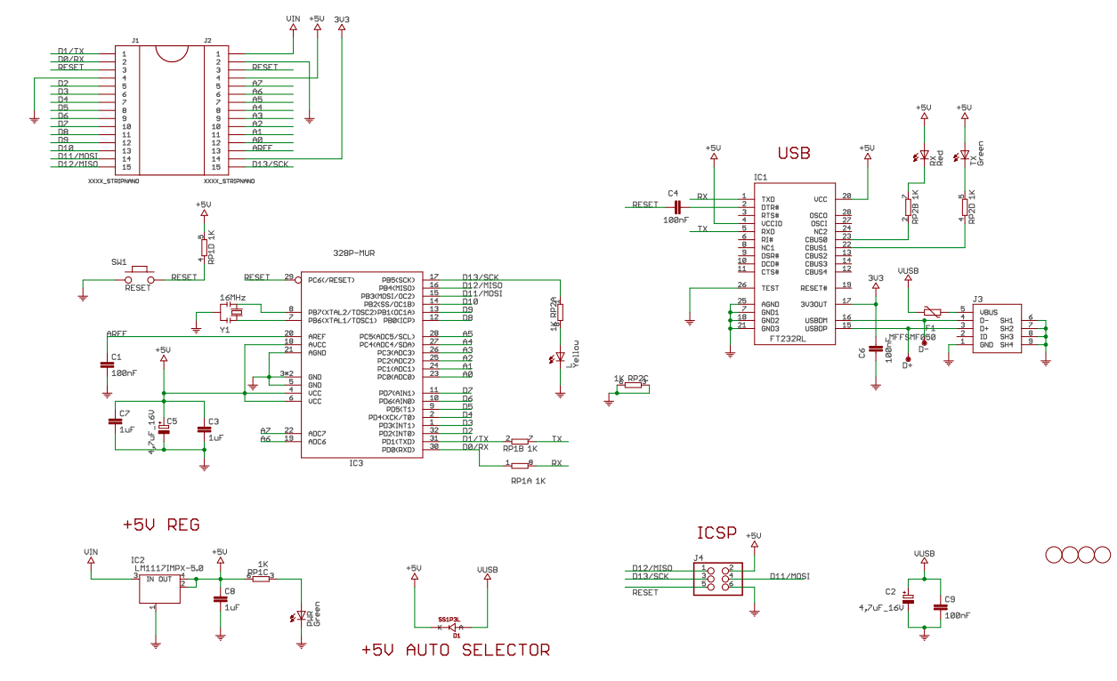

1. Overall architecture

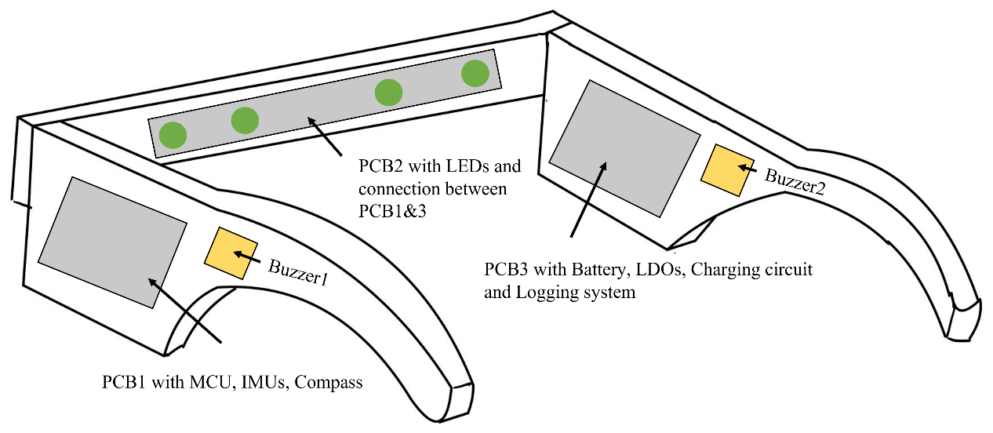

1. Component selection
2. MCU: ATMega328P, which is the MCU for Arduino Nano

The chip is not in stock in any of the university preferred supplier, but it can be bought on eBay and costs about 5 pounds each

1. IMUs: MPU6050, consisting of both accelerometer and gyroscope.

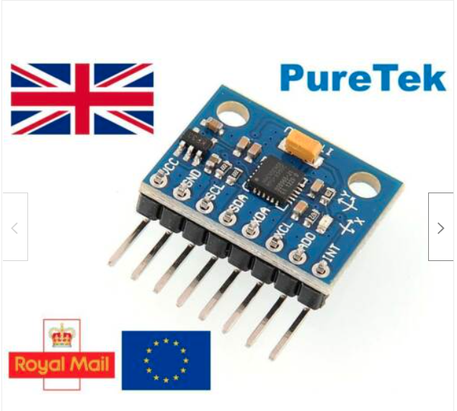

There are many existing tutorials and examples of this IMU. It can communicate with MCU via IIC protocol. The operating current is below 5mA. The range of acceleration could be $±2,4,8,16g$. The sensitivity of gyroscope is $±250,500,1000,2000°/s$.

This chip is again not available in any preferred supplier but also can be found on eBay, in both form of single chip and designed module. Each cost about 4 pounds.

1. Compass: HMC5883, digital compass

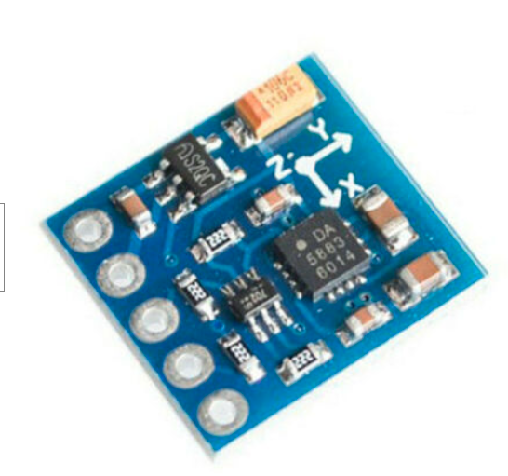

Same as MPU6050, this chip is chosen because there are many examples available. Its interface is also based on IIC. It can provide 1 to 2 degrees of compass heading accuracy. The operating current is below 1 mA.

The chip is also not available from preferred supplier but can be found on eBay, in both form of single chip and designed module. Each cost about 4 pounds.

1. LED: 5mm Green LEDs

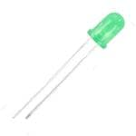

This component can be found in Mouser and the product code is 604-WP7113GD. The typical forward voltage is 2V and the current is 10 mA. Each LED costs about 0.25 pounds.

1. Buzzer: 12mm*12mm*3mm SMD buzzer

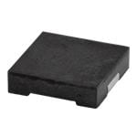

This component can be found in Mouser and the product code is 490-CPT1212381SMTTR. The operating voltage is 5V and the rated current is 5mA. Each buzzer costs about 1 pounds.

1. Power switch: SMD Slide switch

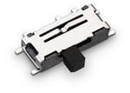

This component can be found in Mouser and the product code is 710-450404015514. The rated voltage is 5V and the rate current is 300 mA. It will be used as a power switch for the entire glasses system. Each switch costs about 0.6 pounds.

1. HMI switch: SMD small tactile button

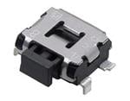

This component can be found in Mouser and the product code is 667-EVQ-9P701P. It supports up to 12V DC and 50mA of current. Two of this button will be used in the project to provide user interaction with the glasses, such as locking onto a direction, turning on/off the buzzer, choosing a new direction etc. Each button costs about 0.2 pounds.

1. SD card: 8GB micro SD card

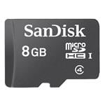

This component can be found in Mouser and the product code is 467-SDSDQAB-008G. 8GB should be more than enough to contain all the data from IMUs and digital compass. Each card costs about 8 pounds.

1. SD card connector: SMT push-push SMT connector

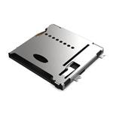

This component can be found in Mouser and the product code is 640-MEM20750014001A. The micro SD card can be pushed into the connector and can be taken out by another push. Each connector costs about 1.5 pounds.

1. USB-TTL Programmer and debugger:

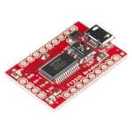

This component can be found in Mouser and the product code is 474-BOB-12731. The chip used in this debugger is FT232RL, which is the USB interface chip selected by Arduino Nano. The original solution of Arduino has integrated this chip onto the development board. It will be used as a separate program downloader and debugger in this glasses project to save more space for other components. Each downloader costs about 12 pounds.

1. Voltage translator: 2-bit bidirectional translator

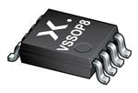

This component can be found in Mouser and the product code is 771-NXB0102DCH. This will be used as voltage translator for the IIC (SCL and SDA) communication between MCU and IMU, also the compass, because the MCU is operating under 5V and sensors are based on 3.3V. The supply current is 40 $μA$ and the translating speed can reach 100 Mb/s. Each translator costs about 0.5 pounds.

1. Resonator: 16MHz ceramic resonator

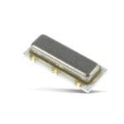

This component can be found in Mouser and the product code is 81-CSTNE16M0V530000R. This will be used as the oscillator for MCU and the MCU can support oscillating frequency up to 20MHz. Its tolerance is 0.5%. The size is 3.5mm*1.5mm. Each oscillator costs about 0.2 pounds.

1. FFC Cable:

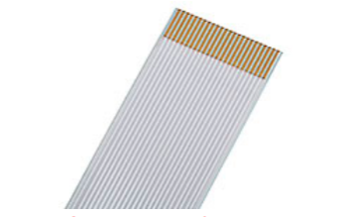

This component can be found in Mouser and the product code is 538-15020-0098. The FFC cable (10 conductors total) is used to connect three boards together for power distribution and component control. Totally two cables are required and each of them costs about 2 pounds. The length is 5cm.

1. FFC connector:

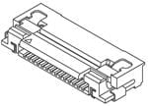

This component can be found in Mouser and the product code is 538-52892-1033. The left leg board and right leg board each has one FFC connector. The middle frame LED board has two of this connector, located at each side for passing the power signal from leg to right board. Totally four connectors are required and each of them costs about 0.6 pounds.

1. Schottky diode:

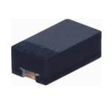

This component can be found in Mouser and the product code is 750-CDBU0520. This diode is used to protect the device when it is powered from external source such as USB debugger. The forward current is 500mA and the forward voltage is 470mV. The size is similar to a 0603 package. Each diode costs about 0.4 pounds.

1. Battery charging management IC:

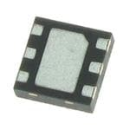

This component can be found in Mouser and the product code is 579-MCP73830LT0AAIMY. This chip is used to charge the Li-Po battery that powering the entire system. It can use the external 5V input to charge the battery at constant current or constant voltage mode, and the max charging current can be configured. The price is this chip is around 0.8 pounds. The size is 2mm * 2mm.

1. LDO (3.3V):

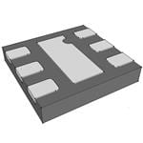

This component can be found in Mouser and the product code is 998-MIC5305-3.3YMLTR. This LDO is used to generate 3.3V power supply for the digital compass and accelerometer, also the micro SD card. The rated output current is 150 mA, which should satisfy the power requirement of those components. The price of this chip is around 0.4 pounds and size is 2mm*2mm.

1. Boost chip (3.7V -> 5V)

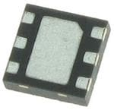

This component can be found in Mouser and the product code is 700-MAX17223ELT+T. This boost chip is used to boost the 3.7V voltage from Li-Po battery to 5V main power supply for the system. This 5V will be used by microprocessor to perform calculation and driving other components such as buzzer and LED. The rate current level is 500 mA, which is much greater than the total power consumption of all components in the system. The price of this chip is around 2 pounds and size is 2mm*2mm.

1. TVS diode

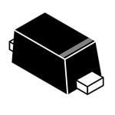

The component can be found in Mouser and the product code is 863-SZESD9101P2T5G. The TVS diode is used to provide protection of the system when the external charging cable is plugged in or removed. TVS diode can absorb a large transient current surge in a very quick manner, protecting the circuit from being damage. The working voltage is 5V and the breakdown voltage is 5.3V. Each diode costs about 0.3 pounds.

1. SMD 0603 Red diode

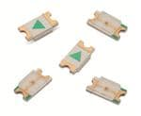

This component can be found in Mouser and the product code is 710-150060RS75000. This small 0603 LED is to indicate the charging status of the system, which will be powered on and off automatically by the charging chip. The LED will be lit up by the charging chip when the battery is not fully charged, and will be powered off when the charging process is complete. Each Led costs about 0.1 pounds.

Week 10&11&12 (11.22-12.12)

1. Supervisor Meeting Minutes:
2. Frequency of PWM: The PWM technique is used to control the on-off, brightness and any other required operation of LEDs. The output voltage from MCU will be 5V, and a resistance between 300 and 400 ohms will be connected in series with each LED to limit the current below 10 mA. Since the human eye can perceive a maximum frequency of light change (on-and-off) at around 25-30 Hz (persistence of vision), any frequency that is much greater than this limit (e.g. 100Hz or more) will satisfy the requirement. The eye can only sense a constant brightness in this condition and the brightness can be adjusted by varying the duty cycle.
3. Frequency of buzzer: The buzzer itself has a frequency response curve describing its maximum sound level at a certain frequency. However the buzzer is very close to ear when installed thus there is no need for a very loud sound. The human ears tend to be less sensitive to low frequency sound ($≈$ 20Hz) and ultra-high frequency sound ($≈20kHz$), a frequency between these two extremes will be a good choice. It can be chosen as the frequency of LED PWM driving signal for easy programming and implementation.

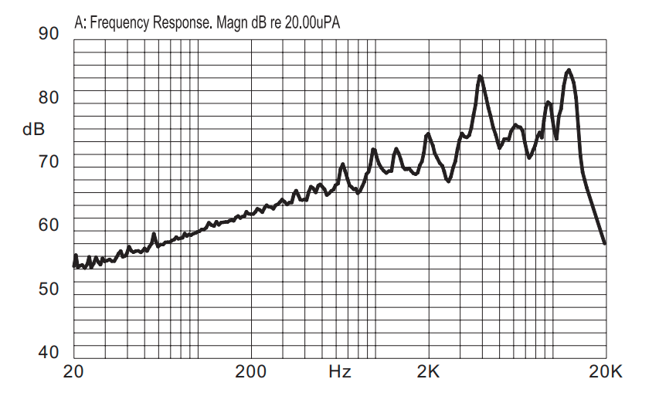

Also, it will be good to choose a buzzing frequency that is not in the human voice bandwidth for the user to easily distinguish the alerting sound from the glasses from other potential noise in the environment. The human earing response to different frequencies is worth an investigation.

1. To have an overall evaluation of the maximum possible power consumption of the system, it should be assumed that all chips, LEDs and other power consuming components are turned on at the same time to a max level. The boost chip and LDO in the system should be able to provide enough current to handle this situation, though it won’t happen in real situation, but it is still necessary to ensure that the microprocessor will not reboot because of a lack of supply current. A certain amount of redundancy, e.g. 20%-50%, should be included to improve the system stability and robustness.
2. Waterproof consideration: There are two possible methods to achieve waterproof feature for this glasses frame. One method is based on a completed sealed case using mechanical pressure, sealing rubber, glues or ultrasonic soldering. All electronic components can be sealed in this case, but different method will have different waterproofing level, usually the plastic ultrasonic soldering will provide the best effect. However this method is not realistic for a prototype but more possible for a large scale production. Another method is based on potting, in which all space in the glasses frame is filled with some kind of liquid that is not electrically conductive but thermally conductive, so that after the liquid hardens and becomes solid, even if the frame is completely soaked into the water, it will not affect the electronics inside because water molecules have nowhere to go. This method is quite practical for the prototype stage and a proper paste/liquid for this purpose can be investigated and apply. One point to note is that it will be impossible to apply further modification to the circuit after this process so it should be confirmed that no further adjustment is needed before pouring the liquid in.
3. The constraining rules in PCB design, e.g. clearance, track width, via diameter, should be confirmed with the manufacturer before generating the Gerber file. Usually a very small clearance and small via diameter will result in a higher production price, especially in small quantities. This is because the yield rate will be reduced and the manufacturer will need to run more rigorous test to ensure that the board delivered to the customer is fully-functional. In this project, the minimum via size for middle frame PCB and right leg PCB is all controlled to be larger than 12mil (0.3mm), so that no extra “via drilling cost” will be caused. However the min via size for left leg PCB is 10mil (0.25mm) because the wiring density in this board is much higher than the other two. It is possible to still use 0.3mm hole but it will take a long time to adjust all the components’ positions and routing scheme, leading to a higher risk of project completion. Further optimisation could be applied to the design after the viva. The minimum order quantity for each board is 5, and the prize for middle frame and right leg board is both 20 dollars. The left leg board, because of the 4-layer design and smaller via size, costs 90 dollars
4. The current middle frame design actually put a lot of restrains to the structure of the glasses frame. The mechanical structure will have to contain that 12mm*140mm size of PCB. There are a few ways to improve that, however may be difficult to realize in the first version of prototype, but is still worth some discussions for the future generation. The best solution will be using a flexible circuit to provide the mechanical supports for LEDs and also provide the electrical connections between left and right board. The terminals of the flexible circuit can be designed to have exposed copper conductors, which can be directly connected with the FFC connectors at the left and right board. Also, LEDs can be directly soldered on the flexible circuit as the previous PCB plan, but now the width of flexible circuit can be at least half of the previous PCB and it is also be folded or bended to suit the shape of the glasses frame. This can give much greater freedom to glasses frame structure design and the middle frame can be much narrower.

2. PCB designs:

The PCB designs are completed using the CAD Altium Designer. An individual project, including schematic, layout, library was generated for each board. These design files are shown below and explained briefly.

1. Left leg board

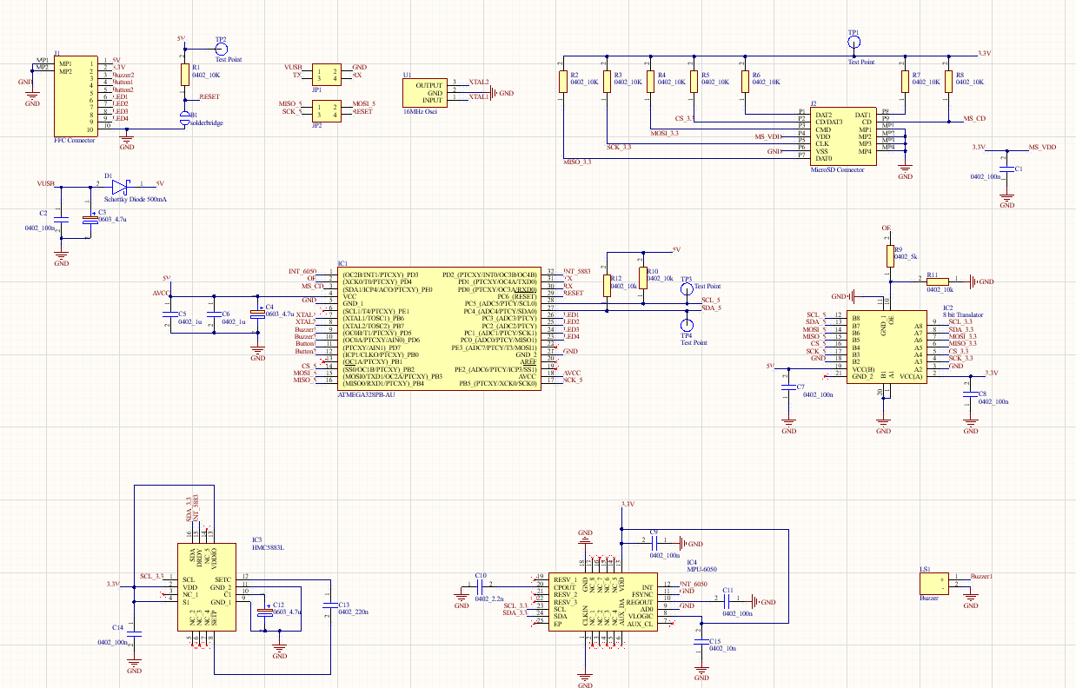

The left leg schematic contains a microprocessor ATMega328P, an accelerometer and gyroscope MPU6050, a magnetometer HMC5883L, an 8-bit voltage translator, a SD card connector, a buzzer, a FFC connector, two four-pin headers and some other resistors and capacitors.

The entire left leg board is powered by the 5V and 3.3V from the right leg board, which are fed into the board by two conductors of FFC connector. The 5V source, however, have a complementary supply method using the 5V voltage from debugger. The 5V from debugger is connected to the 5V bus in the system via two decoupling capacitors and a reverse-protection Schottky diode. The 5V supply is used to power the MCU that is running at 16MHz. The 3.3V supply is used to power the IMUs, digital compass and the micro SD card. The IIC outputs from IMUs and digital compass are connected to the 3.3V side of voltage translator, also the SPI interface of micro SD card. These six pins are converted into 5V for connection with MCU. All outputs of micro SD card are pulled-up to 3.3V. The serial interface for MCU debugging and the SPI interface for Arduino firmware upload are connected to two sets of 4-pin headers for easy access using normal Dupont wires. Totally 10 pins of the FFC conductors are used, and they are 5V, 3.3V, Buzzer 2 on the right leg board, Button 1, Button 2, LED 1~4 and GND.

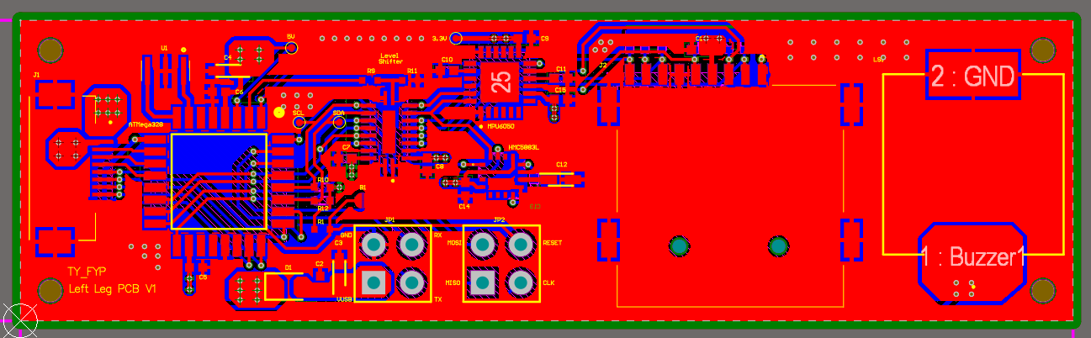

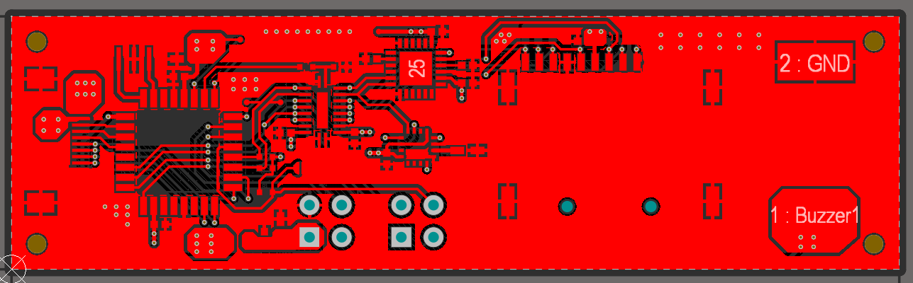

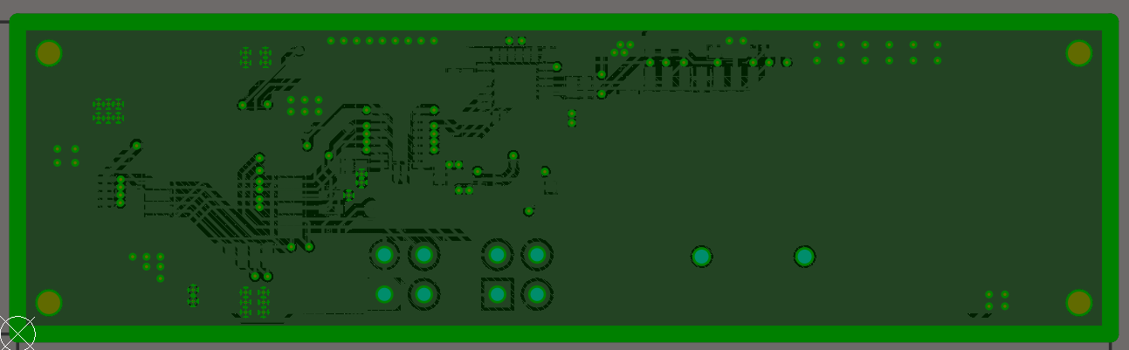

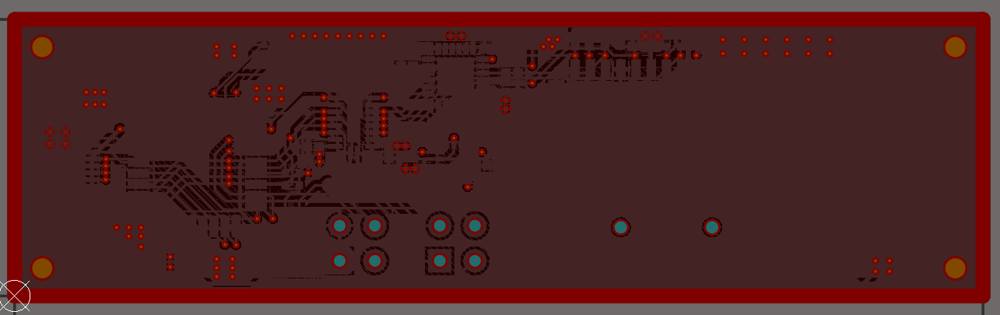

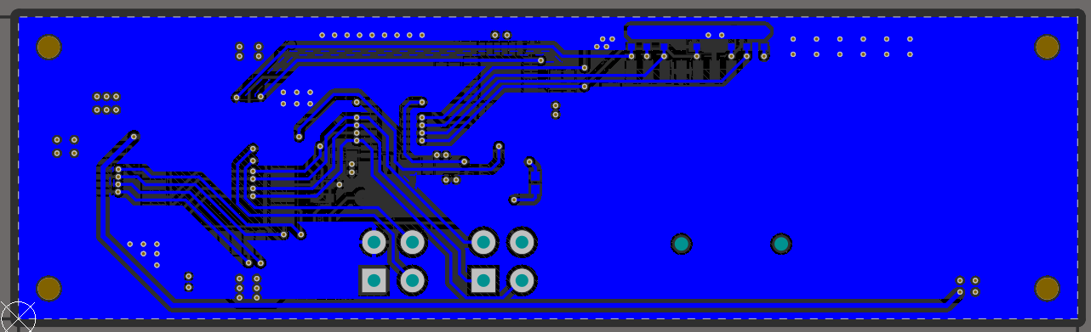

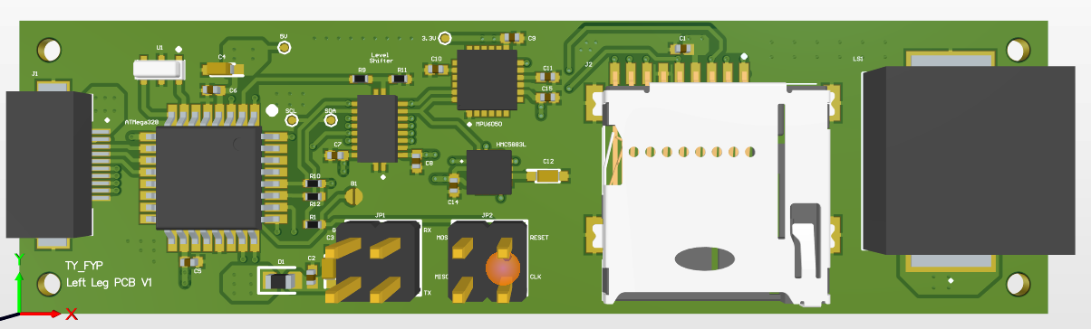

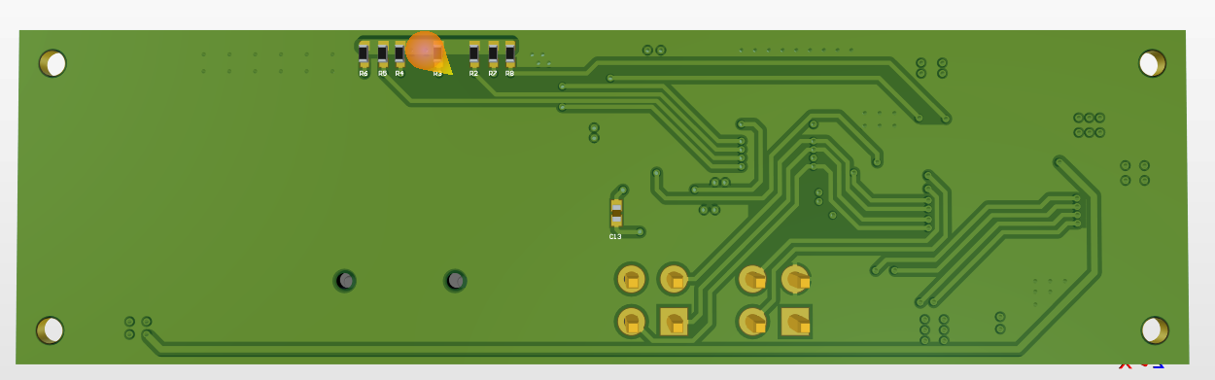

The PCB design of left leg board is based on 4-layer design since the 2-layer option may not be able to realize such as compact design. The size of the board is 20mm*140mm. The top and bottom layers are signal layer for track routing, and the middle two layers are plane layers for 5V and 3.3V supply.

The FFC connector is placed near the left edge for connecting the middle board. The buzzer is placed near the right edge so that it is close to ears and generated sound can be easily captured. The slot of micro SD connector is pointing downward for inserting the card upward when the board in installed into the glasses frame. The voltage translator is placed between the MCU and IMUs, compass and micro SD card for a easy routing scheme. A few testing points such as 5V, 3.3V, SCL, SDA are added to the board for debugging and maintenance convenience.

1. Middle frame board

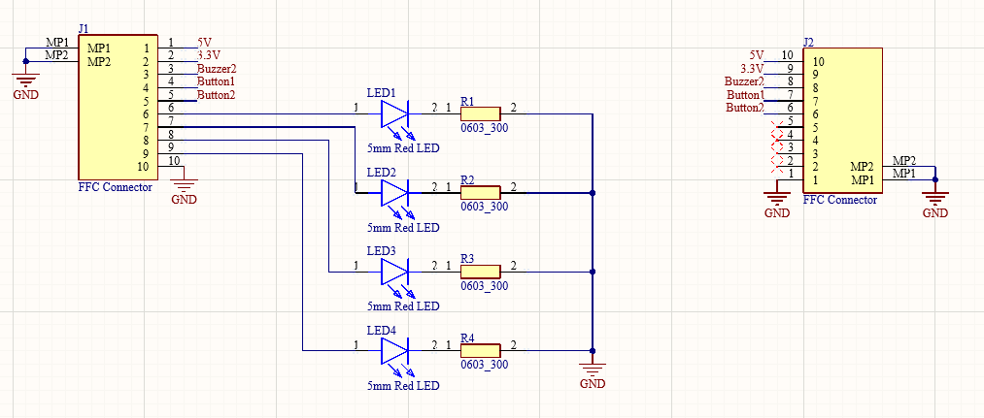

The function of the middle frame board is to provide mechanical and electrical support for four indicating LEDs, meanwhile passing the signal and power between the left leg and right leg board. Two 10-pin FFC connectors are located at each (left and right) terminal of the board for connecting with other two boards. Four of these 10 pins are for LED driving, while the rest are for power transfer and other signals.

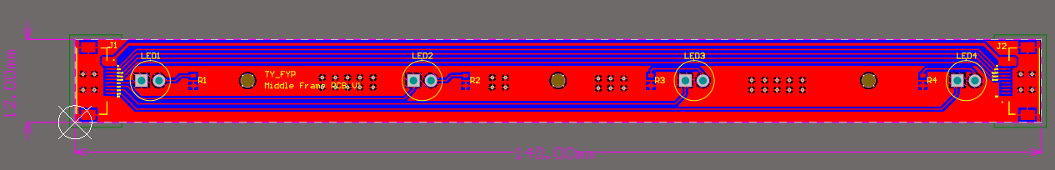

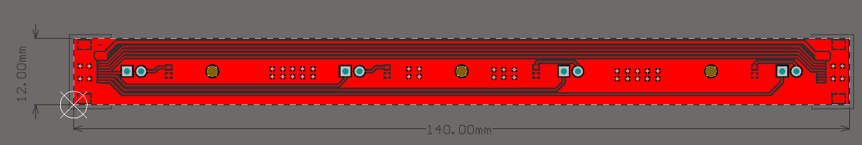

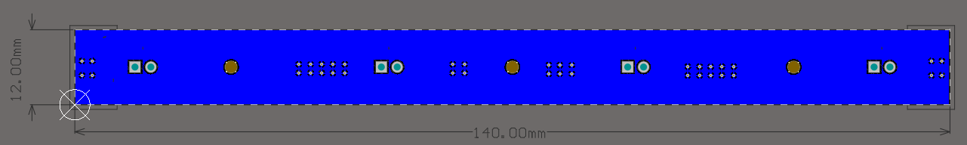

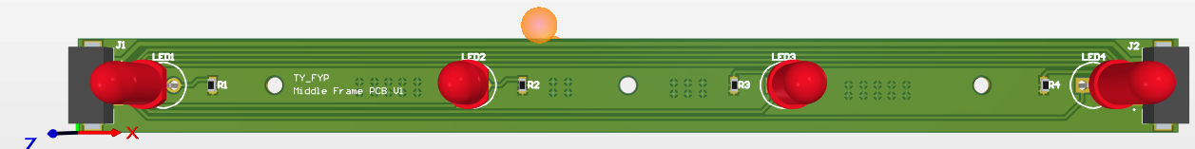

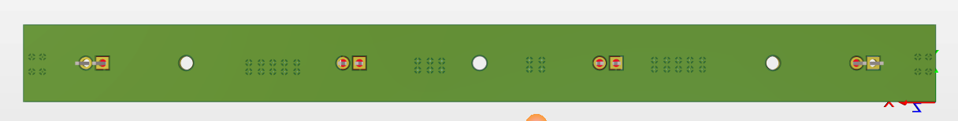

The PCB design of this board is relatively easy. A typical two-layer design is chosen. The width of the board is minimized to be 12mm, which is equivalent to the width of the FFC connector. The distance between each LED is chosen to be relatively large so that the user can easily distinguish which LED is turned on. It should be noted that the through-hole components are shown in the figures above since it is the original design, but SMD LEDs are also purchased to verify their performance and user experience comparing to the through-hole version.

For the potential improvement on the middle board PCB design, it will be much better if the design could be realized by flexible circuit as shown below, since the current design puts great constrains on the shape of the glasses middle frame structure. With the flexible circuit, the shape of the middle frame does not have to be fully straight to contain the 12mm*140mm hard PCB. The flexible circuit could also play the role of holding the components and connecting to the left and right board together, thus the FFC cables can be removed. The shape of the middle frame could also be more versatile to improve the appearance of the glasses and also the user comfort. This design can be implemented in the later generation of the glasses.

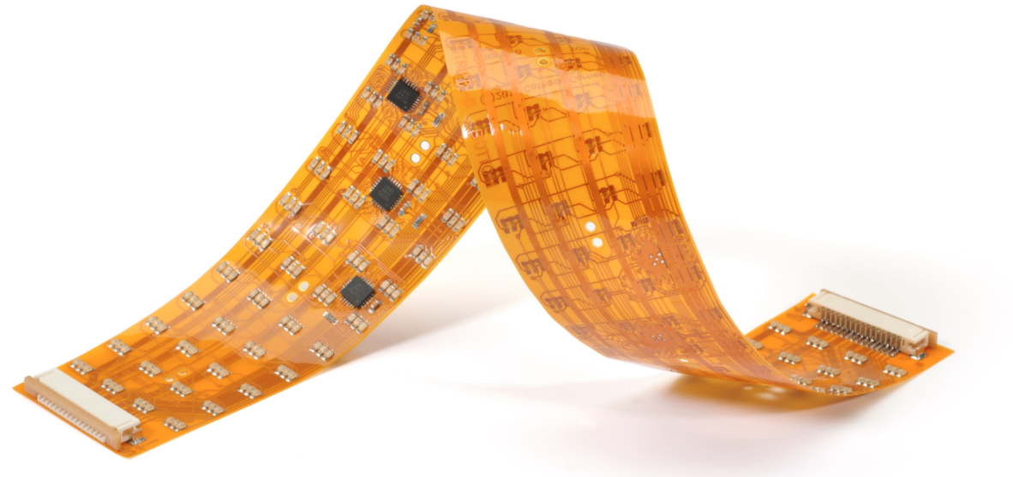

1. Right leg board

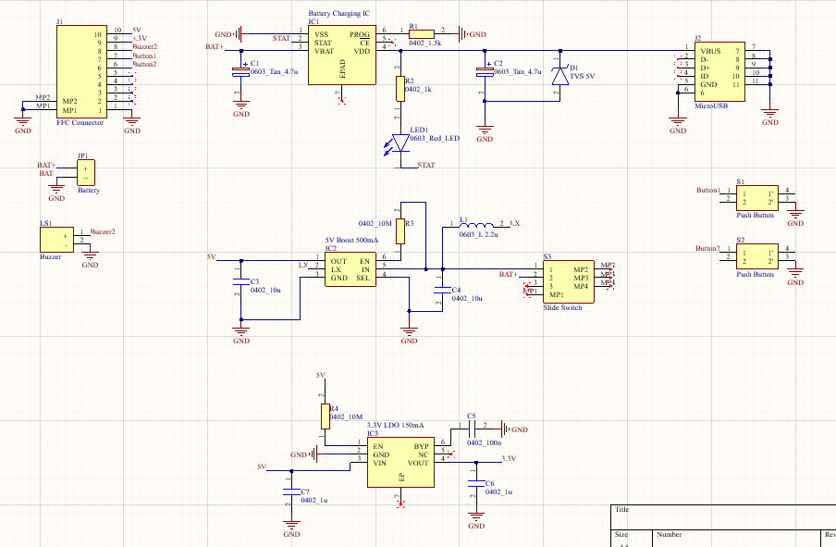

The right leg board provides all different power supplies and battery charging function for the glasses electronic system. There are totally three ICs on this board. One of them is dedicated for battery charging, with a tuneable constant charging current and a LED charging status indicator. The resistance for charging current selection is 1.5k ohms, which sets the current to be 133 mA in the constant current charging mode. The external power source (for battery charging) is fed into the circuit with a micro-USB female port that is only used for charging not debugging. The output power (3.7V) is connected to the boost IC to boost the voltage up to 5V to power the entire 5V bus in the system (mainly the microprocessor). The boosted 5V is then connected to the cascaded 3.3V LDO to convert and regulate the voltage to 3.3V, which is the desired voltage for all the sensors (IMUs, SD card and magnetic meter). This design ensures that the system can still generate 3.3V in autonomy when it is powered from external power source, such as the 5V supply from debugger, so that the debugging efficiency in this prototype can be improved.

There are also one slide switch and two push buttons in this board. The slide switch is the power switch for the entire system, though the battery charging current path is independent of it, so that the battery can always be properly charged in spite of the status of the slide switch. Two push buttons are used for functions like locking to a certain direction, changing to another direction, finishing the current journey etc. They are connected to ground when they are pushed, and on-off detection will be integrated to the controller using external interrupt detection.

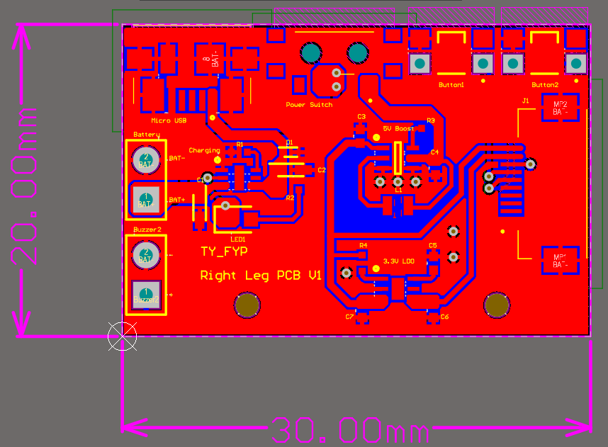

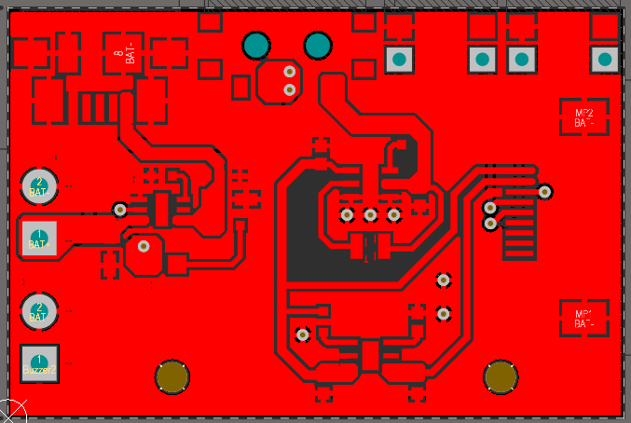

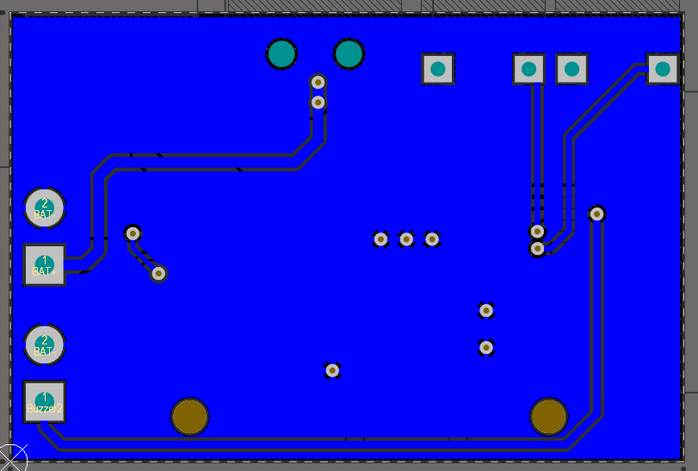

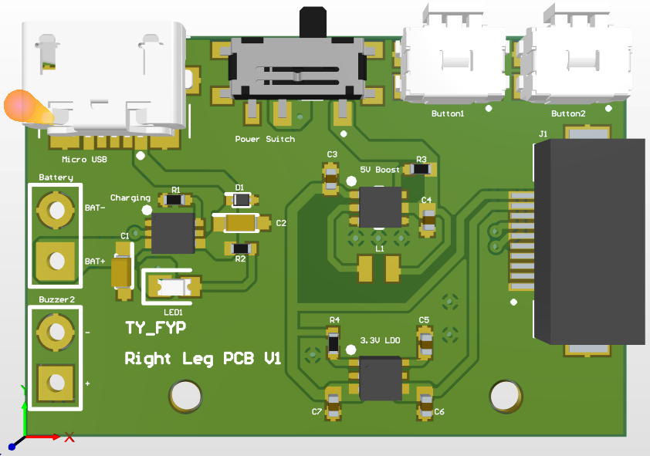

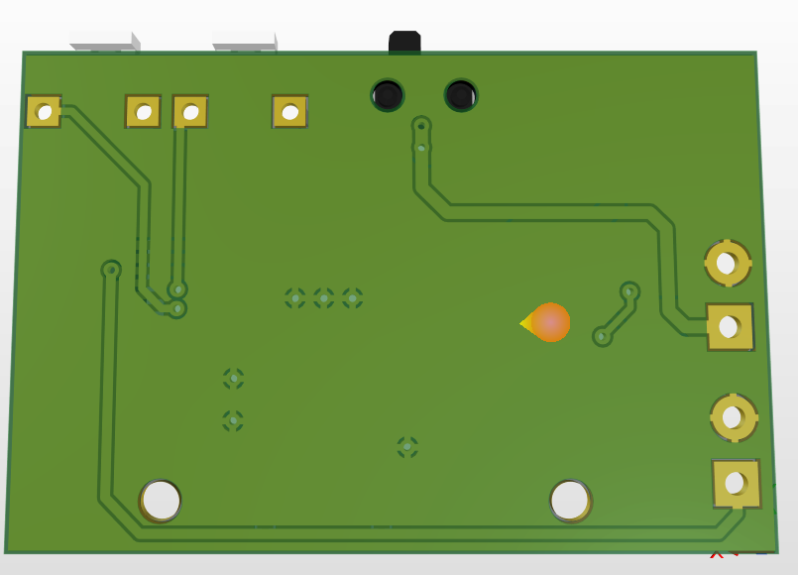

The PCB design of this board is also relatively simple since there are only large current power tracks, no small signals to consider. A typical 2-layer design is chosen for it. The FFC connector is placed at the right side as this board will be installed on the right leg. The slide switch and two push buttons are all placed at the top of the board so that they are easily accessible for user, so does the charging port. The footprints of the battery and buzzer are substituted by standard 2.54mm through holes as they will be connected to the board using wires. This is for thickness consideration as the addition of thicknesses of PCB and battery will be too large to fit into the glasses frame (max 5mm thickness). Additional room for these two components is reversed in the structure design, and the addition of their lengths with the buzzer is 30mm+30mm+10mm=70mm, which is same as the length of the PCB in the left leg, so that two legs will be symmetrical.

Week 20&21 (01.31-02.13)

1. Supervisor meeting minutes
2. The current modelling design of glasses frame is OK. The miniature and compact integration of the glasses frame and the electronic components is quite successful. The “exploded view” of showing the internal structure is a professional way to demonstrate the characteristics of the product to the audience, and this could also be re-used in the final viva examination to assist the presentation. The current “slot” solution for connecting PCBs using FFCs could be improved in the future to enhance water-proof feature, though generally it is acceptable as a prototype version. The vulnerability of FFC should also be considered since its conductivity will be affect if being bended for multiple times, which is common for a pair of glasses.
3. It will be good to think about the high level structure of thesis and what content should be included at an early stage. One could construct a single document to formulate a plan/structure first and fill the gaps one by one during the programming and testing the device. The required test, section and figures could be determined first, the rest of the work is just to follow the previous plan, conduct the test and write descriptions and comments about the figures.
4. For programming the device, generating and designing a high level architecture is important at the beginning. This architecture could define the sequence of the state machine, the functions to realize, the collaboration of different sensors. Regulating these features at the beginning will make sure proper space/functions are reserved and prepared for future integration and update, rather than modifying a lot of codes to include new functionalities.
5. 3D modelling of the glasses frame.

The design of mechanical part of the glasses frame follows the principles of concise, compact, light-weight and comfortable. The number of components is minimized and the number of screws is also minimized, to guarantee easy-assembly and robustness. The entire structure could be broken into three parts to illustrate, the left leg, right leg and frontal frame. An overview figure is included below.

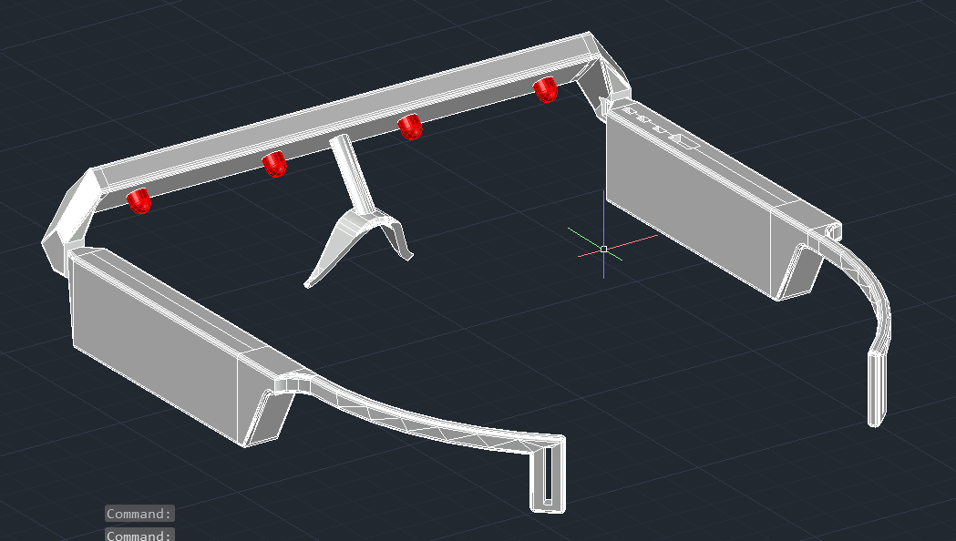

The exploded view could show the internal structure in a better way:

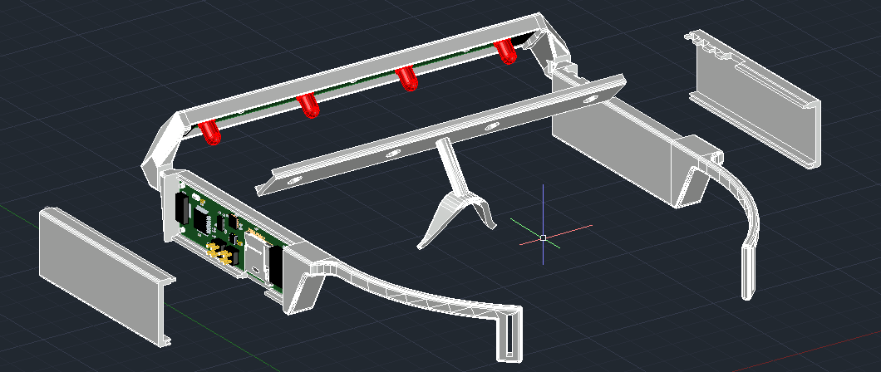

Generally the glasses frame is symmetrical with respect the line that is perpendicular to the middle point of frontal frame, though the specific designs of two legs have some discrepancies due to their different functions.

For the left leg, it consists of a main leg structure and a lid. The lid and the leg form a space of 20mm*70mm*6mm, which is just enough to contain the entire PCB (together with its components) for the left leg. This part of the system is responsible for processing the data, measuring and recording the motional information, and alerting the user via a left buzzer.

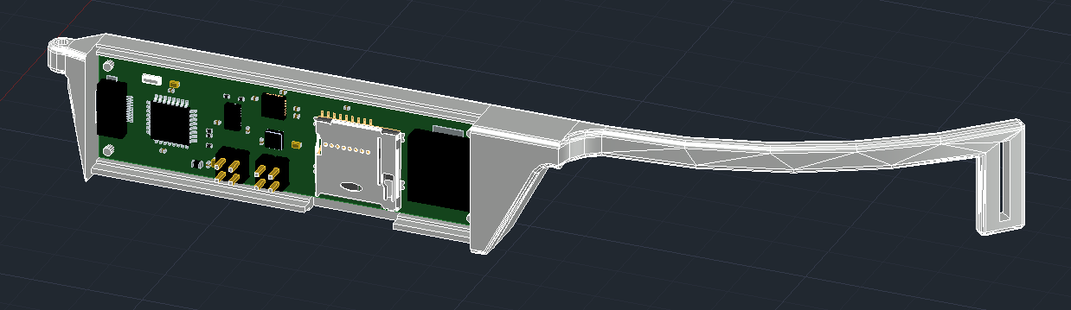

Totally there are two slots in the left leg, one is for the FFC and the other is for inserting and retrieving the micro SD card. The lid is connected to the leg using a “embedding” structure as shown below, which could be firmly attached to the leg without using a screw or any glue. This structure is also appropriate for mass production since the connect could become seamless and permanent by ultrasonic soldering.

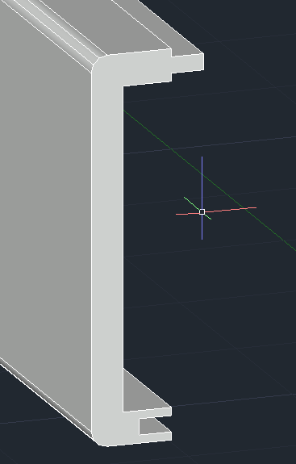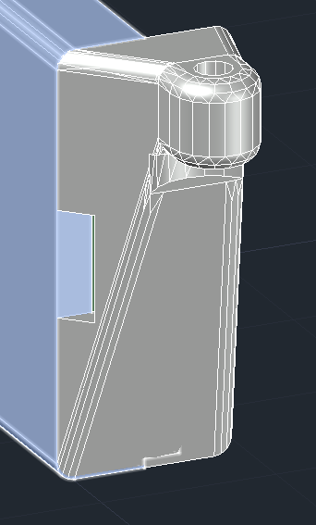

The structure in the left leg that connecting to the hinge system is designed to be compact and smooth. The length of this section is controlled to be minimum, otherwise the length of the leg will be too long to wear. “Fillet” operation in the AutoCAD is applied to nearly all the edges of this section, and it is the same case for other sections of the frame since this will increase comfortability and the whole integrity of the glasses.

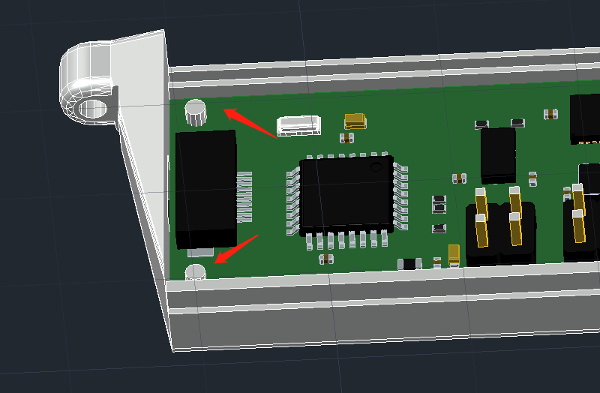

There are additional cylinders located in the corners of the leg to maintain the position of the PCB board when integrated. The position and the size of the cylinder match with the holes on the PCB.

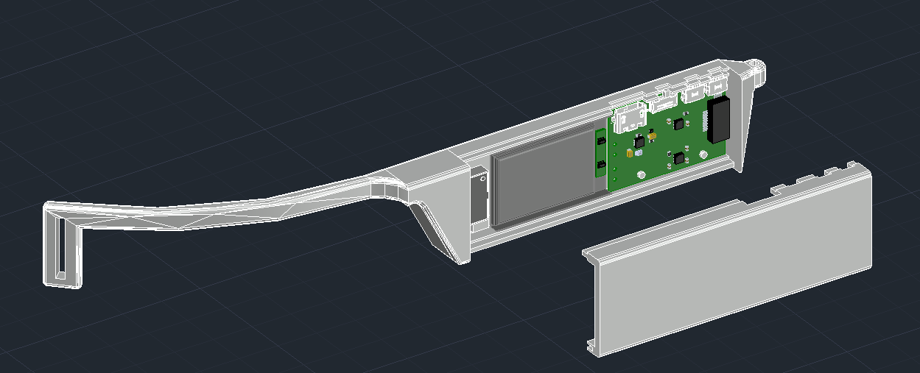

For the right leg, generally its structure is very similar to the left leg with only few differences. The same features will not be repeated again. The space in the right leg is for a 20mm*30mm size PCB, a 20mm*30mm battery and a buzzer. Since the battery and the buzzer are connect to the PCB using wires, additional room is reserved when designing the structure of the right leg. As shown in the figure below, a slot and a mechanical support is created to hold the buzzer in place, so that additional space was created between it and the battery for the wire to go through.

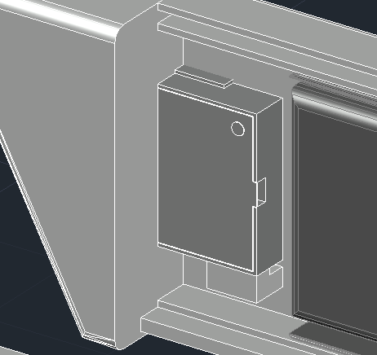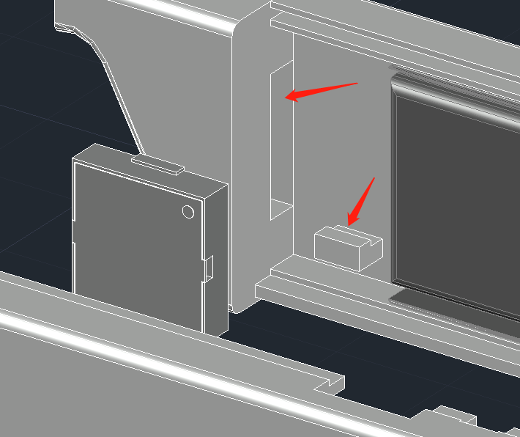

Similarly, a slot is reserved at the bottom of the leg for the wire to go beneath the battery and connect the PCB.

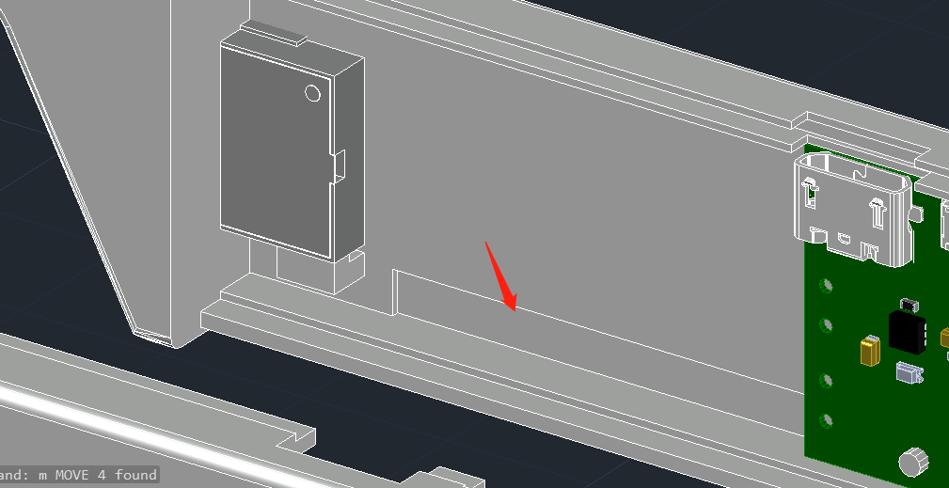

Different from the left leg design, the right leg has four unique slots for the PCB to interact with user. These slots are for micro USB charging, power slide switch, and two customizable user buttons. For this prototype, these four slots have to be arranged in this particular way because they need to match with the PCB design. However, this design could be improved in the future generation since in the current design, the switch and the user buttons are very close to each other thus it could be difficult for the user to find the correct button to choose during orienteering. Despite the size of the PCB is small, the components, such as the micro USB port, can still be re-arranged to other positions to create a large distance between these switch and buttons. The USB port could be moved to the bottom of the PCB, heading downward. In this manner, there is no significant change to the current layout design and the charging port will be more resilient to the external interference such as rain drops/sweating water drops from above.

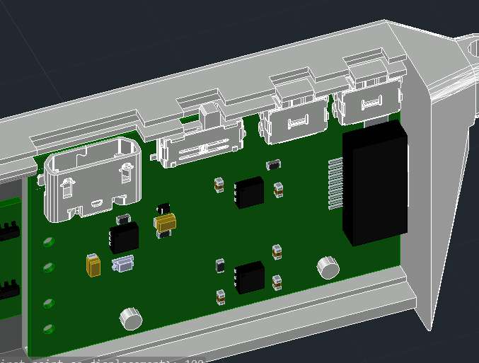

Regarding the frontal frame design, the entire structure forms a complete hinge system with other two legs, and provides a room for the middle PCB with the functions of supporting the LEDS and passing signals between the other two PCBs. There is also a lid together with a nose support for the frontal frame.

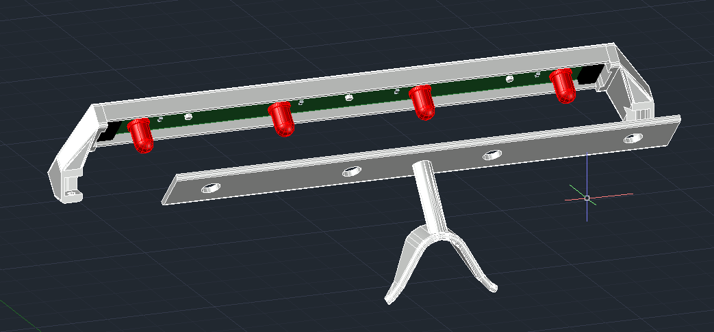

The left and right hinge slots match with the cylindrical shape of the hinge bulge of left leg and right leg. A 2mm hole is used to connect two part of the hinge together using a 2mm bolt, and there is no need for additional nuts. The hole on the hinge bulge is slightly larger than 2mm, thus the bolt will not be able to move when screwed inside the hinge slot, but the hinge bulge is still able to rotate along the blot axis with some friction. The slot is designed to offer the legs some freedom of rotation so that the user will be comfortable when putting on and off the glasses frame, but two legs won’t be able to fully fold inside (be parallel to the frontal frame) like normal glasses.

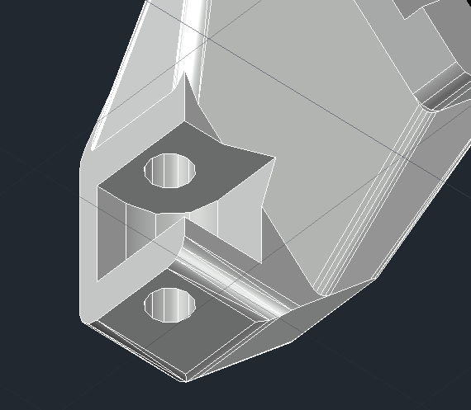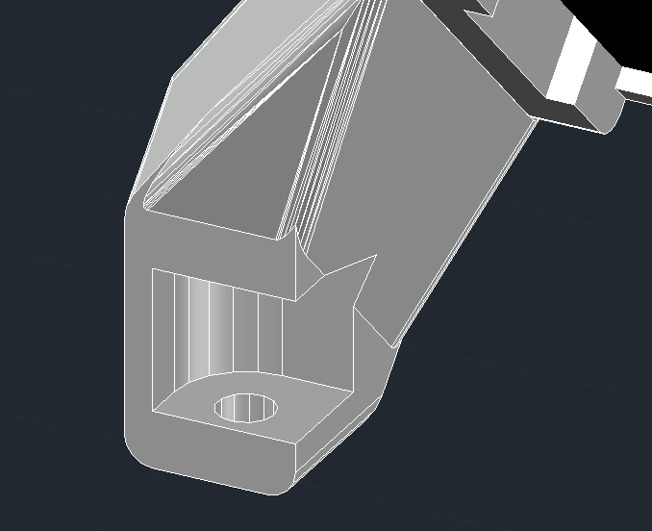

The frontal frame has a tilt design to locate the PCB inside with an angle of 45 degrees as shown in the figure below. This is to mitigate the “oversize” design of middle PCB so that the size of the frontal frame will not be too large horizontally or vertically. Meanwhile, the LEDs are still pointing to the user’s eyes thus there will be no problem for the user to detect the lightings.

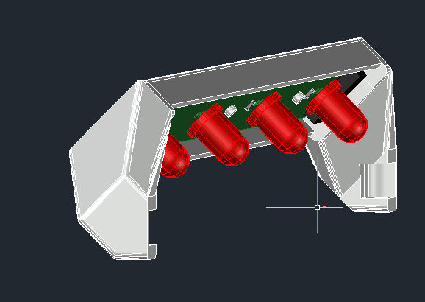

Similar to the leg design, there are also some cylindrical locators in the frontal frame to confirm the position of PCB when installing, and there is a slot for FFC connection at left and right terminals as shown in the figure below.

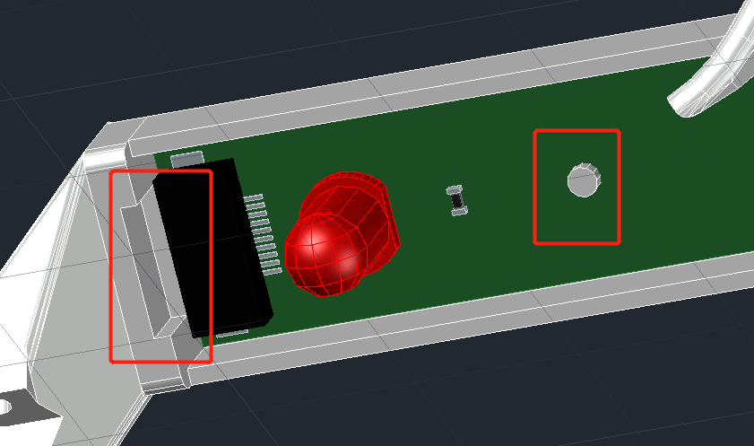

1. Practical issues of 3D printing and the methods to solve them

There are quite a lot of issues (unexpected and expected) exposed during the actual 3D print prototyping process. Some of them are related with the designing stage, where aspects such as length, angle are not properly considered regarding the realistic product, while others are related with 3D printing practical issues like the printer’s tolerance, thickness of each layer or the printing orientation. These issues are included and discussed below:

1. Issue 1: One of the most significant issues is that the method used to connect the lid with the frontal frame/left and right leg is not reliable and robust as the expectation.

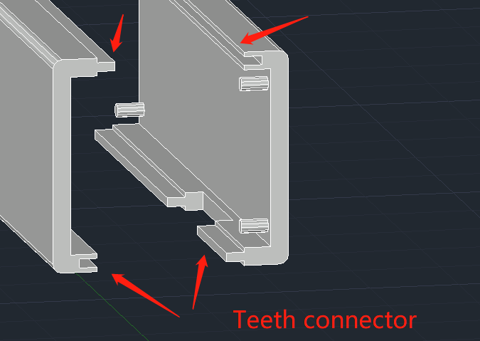

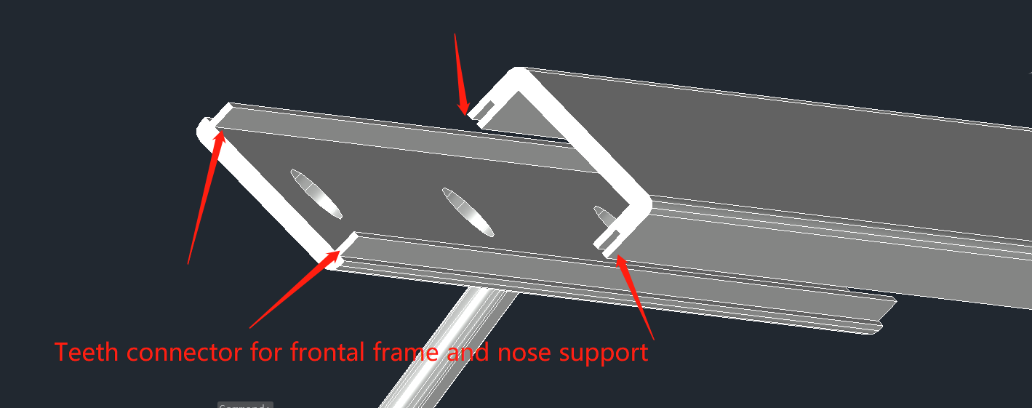

This unreliability is mainly due to the combinational effects from the over-estimation of the printer precision and the strength of the printing material (printing filament). These teeth have the dimensions of 1.5mm/1mm/0.5mm, which are far from reliable after being realized by the 3D printer from the EEE workshop. (This is not saying that the 3D printer from the workshop is a poor model. It is generally saying that these teeth designs cannot be properly realized by normal, affordable commercial 3D printers). The printed teeth are either too large/small to fit together, or their shapes are not straight anymore, owing to the reason that the additional supporting material damages the thin teeth structure, or, the filament is not able to cool down instantly when printing so that the extended teeth becomes curvy.

This problem is fixed, or mitigated, by changing to another connecting scheme or simplifying the structure of the teeth. The first method refers to the modification of the connection between the nose support and frontal frame. The method utilizes the friction between the holes and LEDs to maintain the position of the nose support. When the user is wearing the device, user’s face will apply an additional force that is perpendicular to the frontal frame, so that further push the nose support to the frontal frame. The original teeth and slots on these two components are removed.

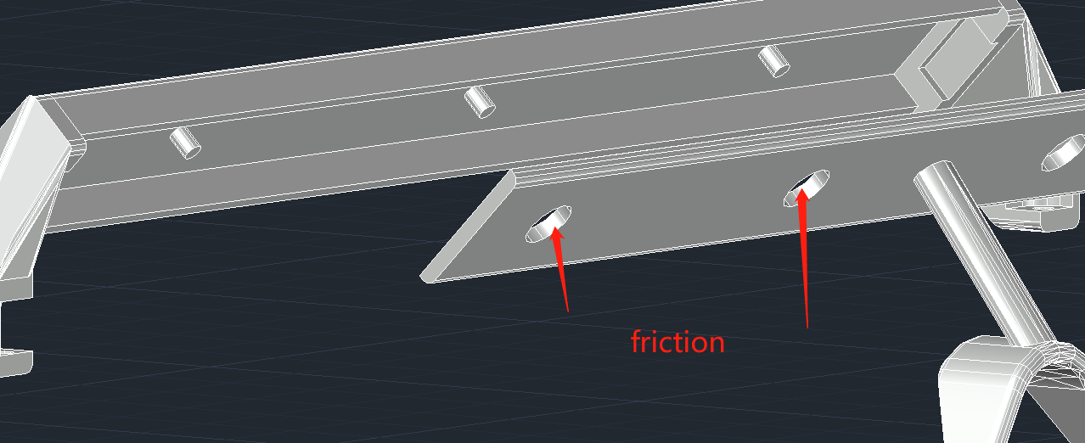

For the connection between the lid and the left/right leg, the design of the slots on the lid remained same, but the teeth on the leg are simplified. This simplified version will not affect the connection solidity, meanwhile also creates additional space inside the leg to give more freedom to the PCB, so that the PCB will definitely be able to fit into the leg despite of the presence of 3D printing tolerance.

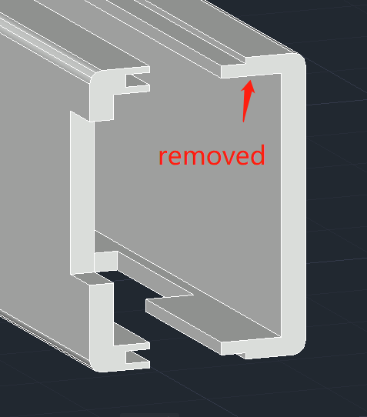

1. Issue 2: Except two lids of legs, the other four components of the glasses frame do not have a “box” like shape, in other words, their shapes are quite irregular. This makes it difficult to preserve all the characteristics during printing. There must be a trade-off, to determine which features of the glasses frame are most important for integrating with electronic components and general prototyping.

In brief, the features that must be preserved are those related with PCB locating and hinge system. There are multiple short cylinders, that correspond to the positions the locating holes on the PCB, extend from the legs and frontal frame. The size and position of these cylinders are critical for a stable and solid PCB mounting. The best way to preserve the shape and position of these cylinders is to print them in a full vertical way, i.e. the printing direction is perpendicular to the round surface. This is easily achievable for the frontal frame, since the original best approach for printing it happens to match with the desired printing direction for cylinders and there is no need for additional supporting material, but this is not the case for legs.

For legs, in order to create the required printing direction, the legs need to be positioned at an “unintuitive” orientation for printing as shown in the figure below. Only in this way the desired printing direction of the cylinders are satisfied. However, this comes with a cost. Much more supporting material is used for this printing method, and also the surface that connects with the supporting material will be uneven after printing. Despite these, as mentioned before, the position and size of the cylinders are the priorities of the printing, thus the surface finish of other sections are sacrificed.

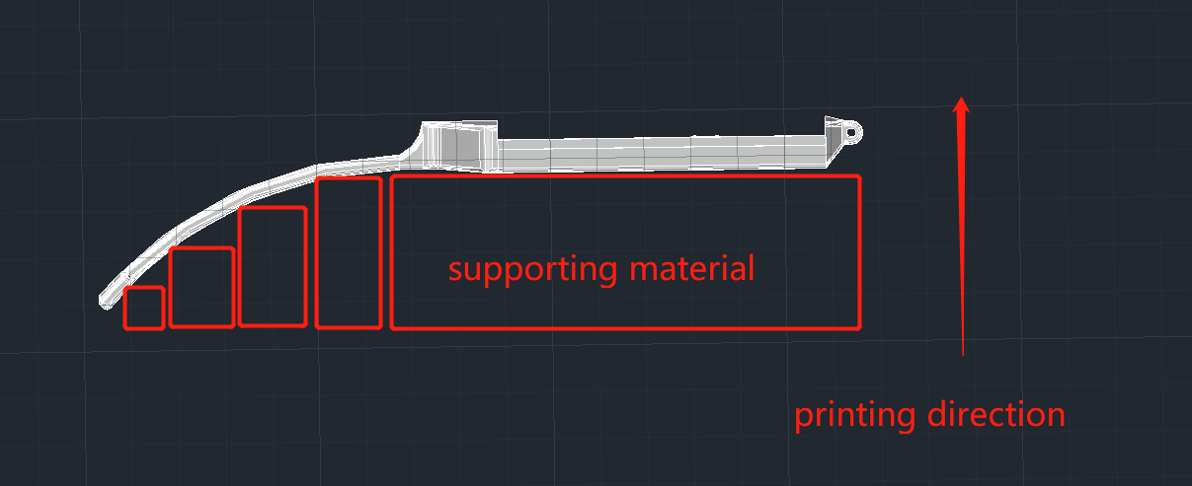

1. Issue 3: The size of the locating cylinders is originally designed to be same as the size of the holes on the PCBs. The aim is to use the same size to maintain the PCBs in position without extra “locator”. However, due to the practical issues of 3D printing, the actual printed cylinders are either larger than expectation or smaller than expectation, which makes it very difficult to install the PCBs. Hence, the following versions of design reduce the size of the cylinder in the CAD file to mitigate this problem, so that the printed cylinder will always have a smaller size comparing to the size of holes on PCBs. The cost is that the smaller diameter will not be able to complete hold the PCB in position, but this can be solved by applying additional glue or double side tape to assist holding.
2. PCB soldering

The PCB soldering is completed based on a soldering iron and a hot air gun, without some specialist tools such as the reflow heating platform or the solder paste, due to the limited resources in the lab. This makes it complicated to solder every component manually because some packages are very small (such as LDO, boost, charging IC and voltage translator). These chips are sensitive to temperature variation and they could be easily destroyed by overheating during the soldering process. Also, because the packages of sensors and voltage translator are leadless and the pads are very small, it is difficult for the solder to melt and attach to the joint surface of the IC’s pads and PCBs’ pads.

One LDO, one boost and one charging IC are required for the full functionality of the right leg PCB, however additional two units were bought for each of them as back-ups. This has been proven necessary as nearly all three chips begin to work properly after the second or the third soldering attempt. It is very difficult to find an appropriate soldering temperature because if the temperature is low, it will take a long time to melt the solder thus the chip will be heated for a long time, but if the temperature is higher, it will take less time but the maximum temperature threshold of the chip could be exceeded. As the solder in the lab is normal manual soldering and the melting point is relatively high (~300 degrees Celsius), this melting point is actually higher than the recommended soldering temperature specified in the chip datasheet, thus the risk is very high.

The difficulty of soldering the FFC connector is also beyond expectation. The performance of the FFC connector will still be affected by soldering process even if it is not a chip, as the connector is made of plastic and it could be melted (damaged) due to the high temperature from the soldering iron. Because of its dense pins, it takes a relatively long time to solder and clean each pin (preventing them from connecting to each other) using flux, then the heat from soldering iron will be conducted to the plastic mechanical package and melt it. Eventually all four connectors are soldered properly without shorted pins, but again, it takes multiple attempts to finish each connector.

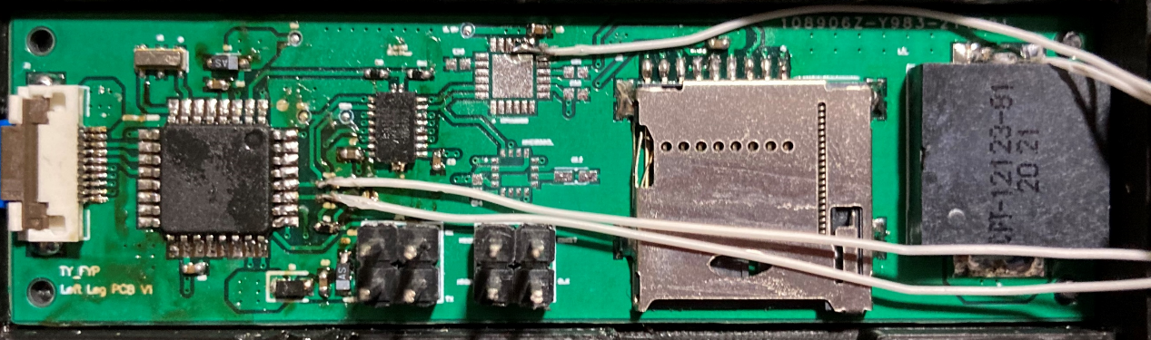

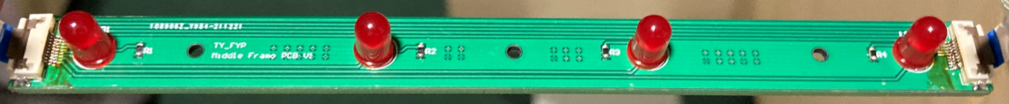

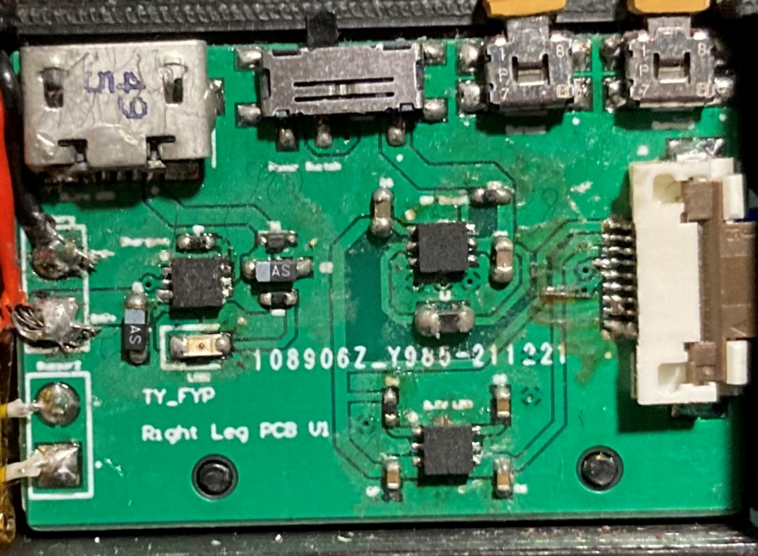

For the debugging ports, two four-pin male headers are soldered for easy accessibility during development. These pins are redundant for the completed product thus could be de-soldered or trimmed off if the program is finalised. Because the footprint of these two headers still takes some space on the PCB, it could be removed in future generations to release the space for other components (other functionalities). The microcontroller could be programmed by external debugger before being soldered to the PCB.

The soldered charging IC could successfully charge the battery with the specified current, but the LED indicator is not working as expected, that is, being lit up during charging and being turned off when the battery is fully charged. The LED could never be lit up during the development. The actual reason is unknown, but it is most likely due to the poor soldering process. The relevant pins of the charging IC are not firmly soldered to the PCB so that the current could be conducted. This problem could be fixed by a re-soldering attempt or a replacement of the chip, but since the chip on board is already the last chip available (the others are damaged in previous soldering attempts), this LED problem is temporarily ignored in the development as it is not critical.

The soldering results are generally acceptable, but this manual soldering process without solder paste and heating platform is not recommended for the next development/project due to its high risk, low efficiency and low reliability. This soldering method is not even appropriate for the development of a prototype because the engineer will spend a long time soldering and debugging the device because of the lack of proper equipment, rather than focusing on the engineering decisions and other realisations of the core functions.

Week 22&23 (02.14-02.27)

1. Electronic system debugging
2. Voltage translator: The issue of the voltage translator is one of the most significant problems in this project. The voltage translator is responsible for interfacing the microcontroller (5V) with the IIC based inertial sensors (3.3V) and SPI based micro SD card (3.3V). As the IIC protocol is based on open drain IO driving and SPI is based on push and pull IO driving, the chosen mode of voltage translator must be compatible with both protocols to successfully fulfil the requirements. However, the chosen model of NXB0108 is a model specifically designed with low static drive strength, which is applicable for communications based on push-and-pull IOs such as SPI. It would not be able to provide enough driving strength for open-drain applications such IIC. Thus in the debugging process the inertial module and magnetic meter could never establish stable communication with the microprocessor, though the communication with SD card is working properly. To temporarily resolve this issue, the IMU chip and magnetic meter chip were removed from the PCB and two existing modules containing the identical chips were connected to the microprocessor directly via some wires as shown in Figure below. They had the exact same functions as the chips on boards and this would make sure the prototype could still be demonstrated to the stakeholders within the time allowance (there was not enough time to manufacture another version of PCB).

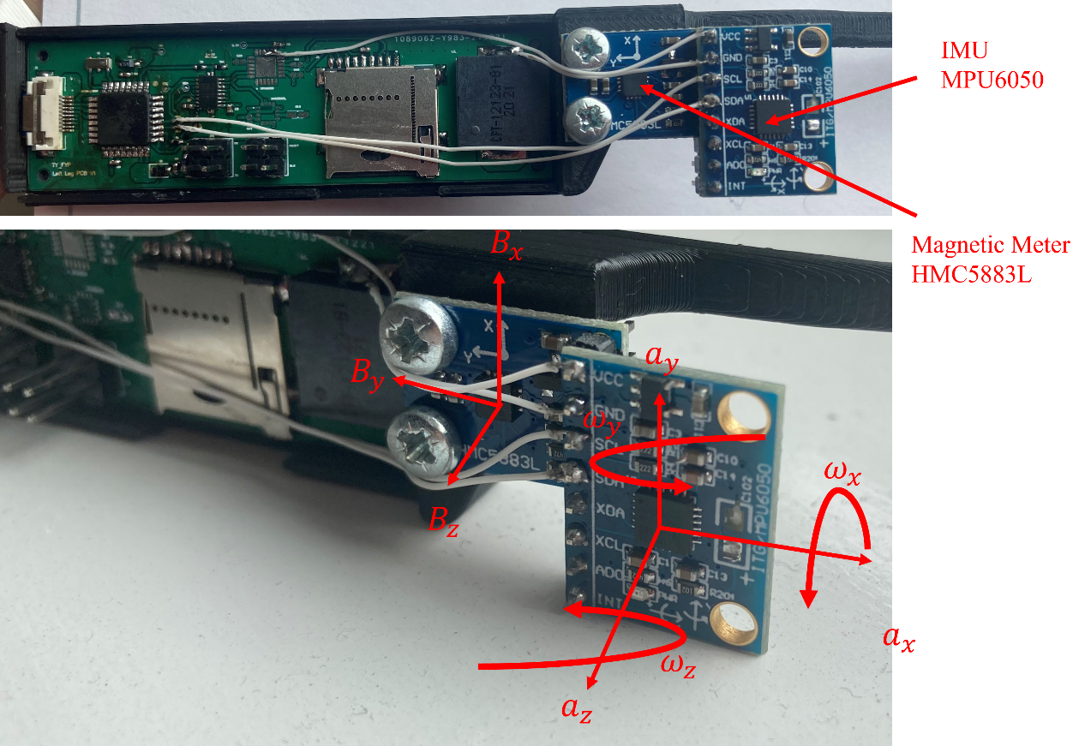

The best method to correct this mistake in future generation was to choose another 4-channel voltage translator designed for push-and-pull driving to ensure the operation of micro SD card, and establish the IIC communication only using the pull-up voltage of 3.3 V as shown in Figure below. The 3.3 V voltage level would be recognised as a “logic high” in both 3.3V and 5 V system, and the chip running on 3.3 V would not be damaged by excessive voltage because the IO driving was realised by 3.3 V source via a pull-up resistor.

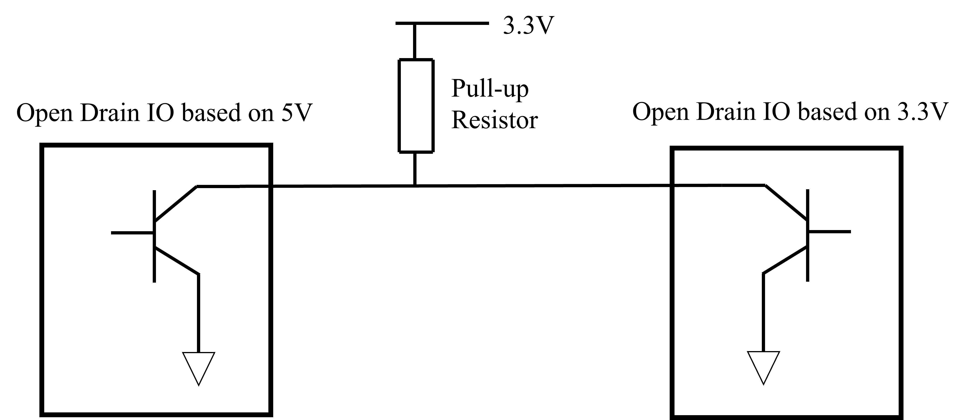

1. MPU6050 CPOUT: This is a peripheral capacitor of MPU6050, which is responsible for boosting the power supply voltage of 3.3V to the high voltage requirement (tens of volts) for the internal oscillator. Technically, because this capacitor needs to undertake a much higher voltage, a different model (higher voltage rating) should be selected in the designing stage, but this higher voltage requirement is missed during designing thus the purchased model is not appropriate. This did not cause significant problems in the development because an additional module is implemented anyway but should be fixed in future generations.
2. Programming
3. High level architecture

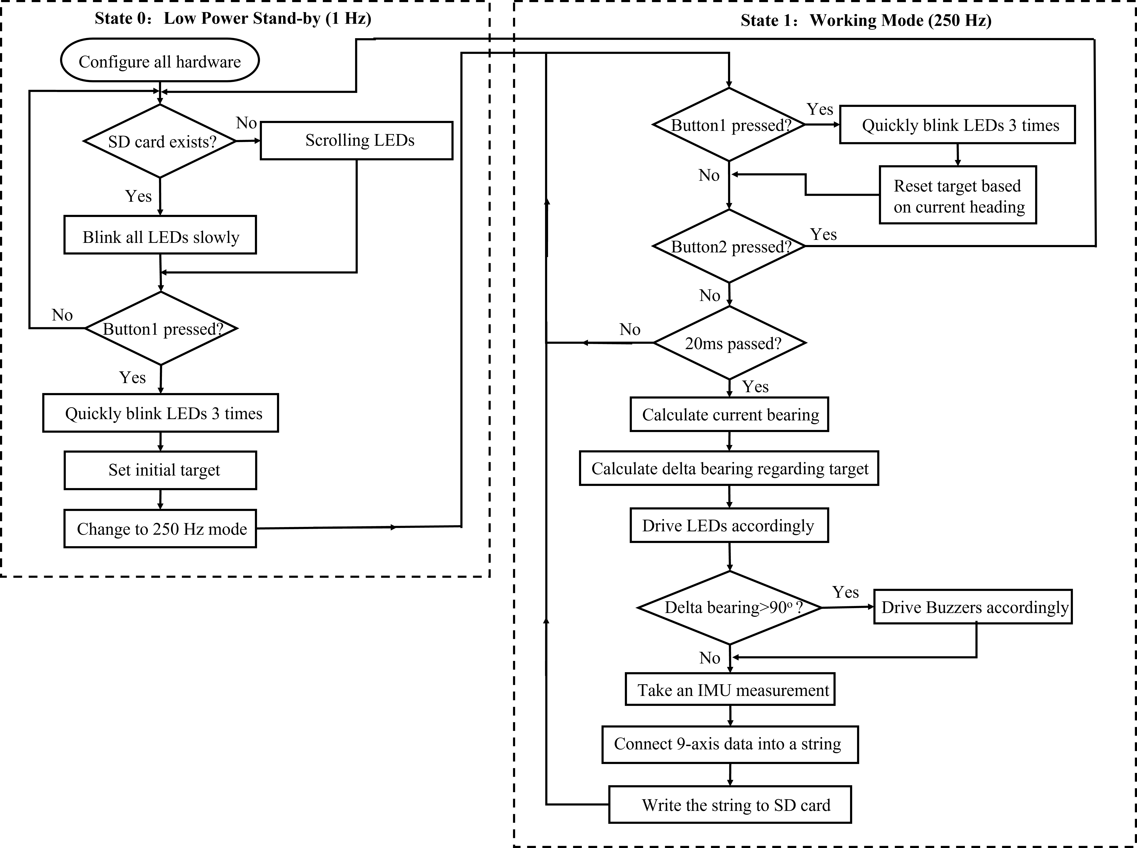

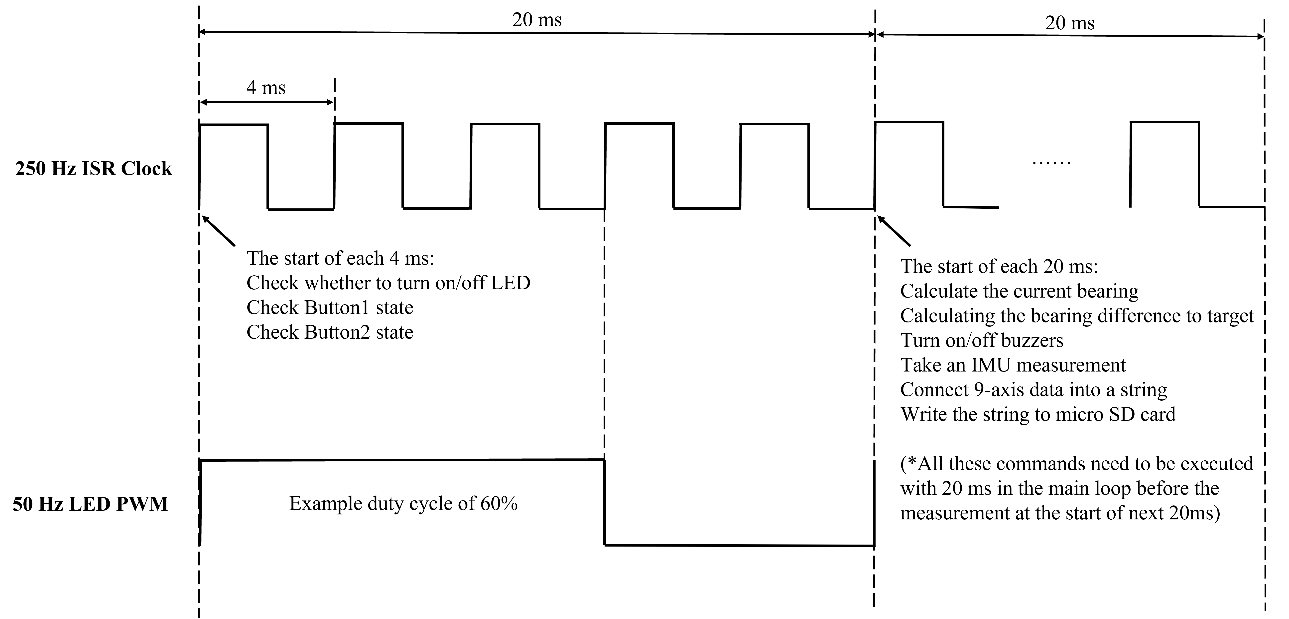

The program of glasses frame was mainly based on a state machine with various timers and ISR (Interrupt Service Routine) operations. As shown in the Figures above, it was consisting of State 0 and State 1. The State 0 was a stand-by mode, in which the glasses frame worked at a very low frequency (1 Hz) to maximally save power and kept waiting for user to press Button1 to start the journey. In this state the program also kept checking the existence of micro SD card so that the user could insert the SD card any time before pressing the Button1 and the program would initialise the card. If the Button1 was pressed, all LEDs would quickly blink three times to indicate the start and the program would enter State 1.

The State 1 was a working routine to realise all guiding and data recording functions running at 250 Hz. This state was more complex than State 0 thus an additional Figure was included to illustrate the time sequence of different activities. Timing issue was critical in this project since the recorded data would be used for double integration in the subsequent signal processing.

The 250 Hz ISR in State 1 and the 1 Hz ISR in State 0 were realised by using Timer1 in the microcontroller as an interrupt trigger source. The 250 Hz ISR had two functions. One was to generate a bit-banging PWM (Pulse-Width Modulation) signal to drive 4 LEDs with a duty cycle resolution of 20%. The PWM method was a convenience way to achieve dimmable LEDs and this characteristic was important for orienteering as the players could be running in both bright and low-light conditions. It had been stated in some research papers that the human eyes would not be able to perceive the flicker if the LED PWM frequency was higher than 24 Hz, while the brightness stability would be higher if the frequency was higher. 50 Hz was selected to be PWM frequency in this project since it was more than two times larger than the threshold value. The period of 50 Hz PWM was 20 ms and it was consisting of five period of the 250Hz ISR, hence there were five different possibilities of PWM duty cycles, leading to a resolution of 20%.

Another reason for choosing the 50 Hz PWM corresponded to the second function of 250 Hz ISR, that was, providing an accurate 50 Hz clock to take measurements and record the data into micro SD card. Because 50 Hz was also a good choice of sampling frequency of sensors in the glasses frame (not too low to miss the motional information, not too high to cause huge burden for the microcontroller), using the same 50 Hz for both sampling and LED PWM could save resources (fewer counter variables and simpler code structure) in the microcontroller. Assuming each 20 ms was a frame as shown in the time sequence figure above, the 250 Hz ISR would keep checking the states of Button1 and Button2 (based on flags from external interrupt) and turn on/off the LEDs according to the pre-determined duty cycle option within each frame. At the end of each frame (which was also the start of the next frame), a flag that would enable the sensor measurements and data recording in the main loop was raised. The microcontroller would use the idle time (no interrupt was requested) in the next 20 ms (next frame) to complete the tasks of calculating current bearing, calculating the bearing difference to target, driving buzzers accordingly, taking IMU measurements and storing the data from current measurement into micro SD card. An example section of stored data was shown in Figure 5-26. The same process would repeat again at the end of next frame. It had been validated that the chosen microcontroller was able to fulfil the above requirement at the frequency of 50 Hz, though a higher frequency might be not feasible.

The bit-banging PWM was not an efficient choice for a microcontroller, but the ATMega328P lacked sufficient resources to realise hardware-based PWM output for all four LEDs without involving any dedicated LED driving chip. The software bit-banging was the only choice. The driving of buzzers, however, successfully exploited the hardware PWM output from Timer0 at 980 Hz. Timer0 was used to control the timing of many default functions in Arduino libraries such as delay(). Changing its frequency would lead to the malfunction of many built-in functions thus the default setting was preserved. According to the human earing response to sound frequency shown in Figure below, human ears were relatively sensitive to the sound at 980 Hz thus this default frequency was adopted.

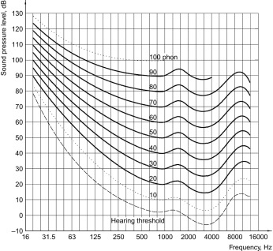

1. Practical Programming Problems:

The actual architecture of the program in the glasses frame has been explained in detail in the thesis, thus the logbook will cover some practical issues that are not covered in the thesis due to page limitation.

Issue 1: The glasses frame will enter the program main loop successfully when the uploaded program is relatively simple, i.e., the flowchart is short and computational requirement is not demanding, but it sometimes will fail to enter the program main loop when the uploaded program becomes more complex. This phenomenon appears to be random thus it is very difficult to get rid of it. A system reboot could sometimes solve this problem. The actual cause of it is still unknown, but it is likely due to the hardware problem, specifically the power supply system. It is possible that instantaneous current requirement during system initialisation is much larger than the normal current requirement of the system, so that the chosen models of LDO and Boost chips are not able to provide enough current to complete the initialisation, particularly when the uploaded code is complex. However this is just a hypothesis yet to be proven, the actual reasons behind this problem could be determined by another iteration of the hardware PCB design.

Issue 2: The current program does not take into account the scenarios that the glasses frame is upside down or in other unusual attitudes. Currently the LED interface and buzzers will produce unpredictable results when the glasses frame is placed in these unusual attitudes. For a better robustness and user experience, all attitudes should be considered in future enhancements and appropriate feedback (or the pause of the system) should be provided to user instead of meaningless light and sounds.

Issue 3: The current target resetting algorithm will fail to refresh the target, or set it to a wrong value in some cases for unknown reasons. The glasses frame is programmed to take eight different measurements of the current magnetic heading and use the average value of them as the new target, if user choose to reset the target. If the average value is still a wrong value, it is likely that the specific codes for magnetic sensor does not synchronous well with the main loop or the codes for target resetting. A better code structure could possibly solve this problem, but it still needs to be ensured that the 50Hz sampling process of all sensors (for micro SD card recording) should not be interrupt during the target resetting sequence, otherwise the subsequent double integration will not be accurate.